SOLOR Working Meeting Minutes: 2/13/2017
SOLOR Participant | Title | Affiliation | Attending
Jane Cook | Specialist Master | Deloitte
Keith E. Campbell | Medical Informaticist  Director of Informatics Arch | VA | regrets
Avaretta (Avey) Davis | Director of Clinical Transformation OCNIO | VA | x
Catherine Hoang | Program Manager, KBS Terminology team | VA
Sarita Keni | Clinical Terminologist/Informaticist | VA | x
John Kilbourne | Informaticist | VA | x
Deb Konicek | Specialist Leader | Deloitte | x
Jay Lyle | Terminologist | JP Systems | x
Susan Matney | Medical Informaticist | Intermountain | x
Liz McCool | Terminologist | VA | x
Holly Miller | Deputy Program Manager | VA | x
Christine Spisla | Senior Consultant | Deloitte | x
Monique van Berkum | Physician Terminologist | VA | x
Tim Williams | Senior Consultant | Deloitte | x
Tisha Scott | Project Manager | VA
Susan Castillo |  | Informatics

Minutes
- Strategic Plan
  - Concept Development
    - Need develop process
    - Concepts needed to represent the model
      - Discuss the patterns – does the pattern fit the problem?
        - Assertion
        - EvaluationResult
        - Procedure
      - Metadata – Monday Feb. 27 with Claude
        - Terminology vs. logical model
      - Value sets
        - How to create and maintain as ref sets
        - Binding
        - VSAC?
    - New Concepts
      - Fit into the model we have
      - Not in the model we have
        - How to deal with new attributes that may extend the concept model
        - Model properties/attributes –
          - Identify the use case
          - Develop a model and plan
      - Issues/Concerns
        - SNOMED CT is limited in what in can say.
          - Complex precoordination e.g. tunneling of wound at 1:00 on the clockface
        - Why do we need yet another format to represent the information model?
  - Monique presented this information during the above discussion

Below is an excerpt of some data related to wound undermining that might be captured in the VHA or CIMI project. LOINC and SNOMED CT concepts associated with some of the data elements are also shown
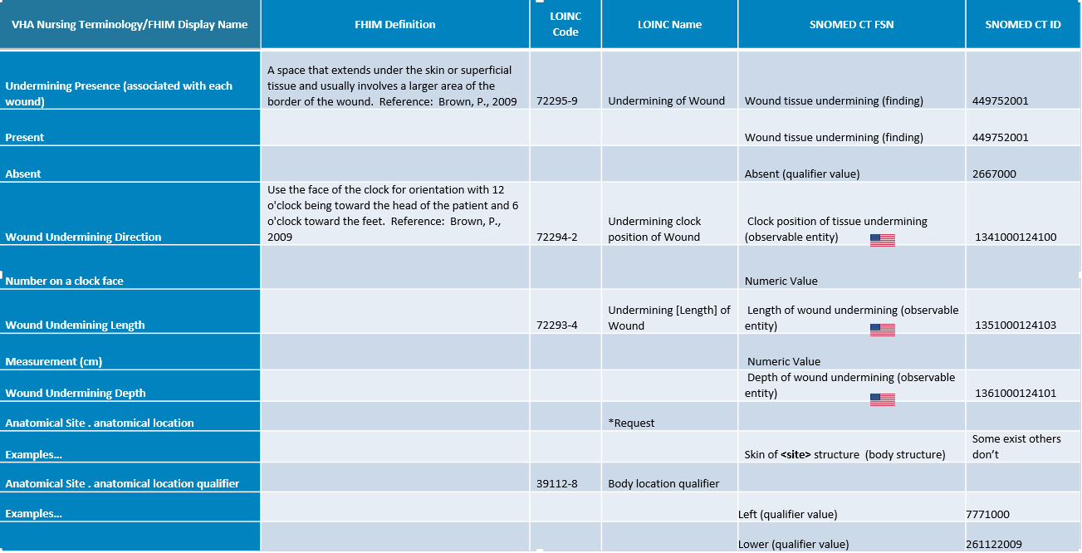

One possible model to capture and combine related data elements into a single observation result is shown below. This is a very preliminary model that would require further evaluation and testing.
LEGO: |Wound tissue undermining of <site> (finding)|: Present at 1 o’clock, 2 cm in length, 0.5 cm in depth (observation result)
↓ Discernable Expression: 363787002 |Observable entity (observable entity)|
↓ Relation Type: 704647008 |Is about (attribute)|
→ Destination Expression: Post-coordinated (or pre-coordinated expression):
=== 449752001 |Wound tissue undermining (finding)|:
{ 116676008 |Associated morphology (attribute)| = 13924000 |Wound (morphologic abnormality)|,
363698007 |Finding site (attribute)| = |Skin structure of <site> (body structure)|*
→ Value: 52101004 |Present (qualifier value)|**
↓ 704318007 |Property type (attribute)|:272485000 |Clockface position (qualifier value)|
→246514001 |Units (attribute)|: 258704007 |clockface hours (qualifier value)|: 1
↓ 704318007 |Property type (attribute)|: 410668003 |Length property (qualifier value)|:
→246514001 |Units (attribute)|: 258673006 |millimeter (qualifier value)|: 20
↓ 704318007 |Property type (attribute)|: 131197000 |Depth (qualifier value)|:
→246514001 |Units (attribute)|: 258673006 |millimeter (qualifier value)|: 5

*Some |Skin structure of <site> (body structure)| concepts might need to be added and some concepts might need to be further modified (e.g., with 272741003 |Laterality (attribute)| = 24028007 |Right (qualifier value)| OR 7771000 |Left (qualifier value)|). This has additional implications with respect to possible tooling and/or concept model limitations.

  - Projects
    - Wound assessment
      - What are Clinical LOINC, SNOMED and “something else”
      - Develop attributes for defining clinical observations
        - Evaluate the current observation model
    - ACOG (next level)
      - What are Clinical LOINC, SNOMED and “something else”
      - Susan present analysis
- Skin/Wound assessment modeling and mapping
  - Review CIMI HL7 project wound assessment model
  - Review the data
- Tooling Updates
  - Onstoserver
  - HSPC Confluence
- CIMI metadata
  - Claude Nanjo to present CIMI patterns 2/27

