Phase Section:
Color Grid:
Note to authors: In the detail section, one simplification technique that appears to have worked was to combine the “Description” and “Rationale” buckets into one. That gives 1-2 sentences of what the milestone is, followed by a sentence or so explaining why.
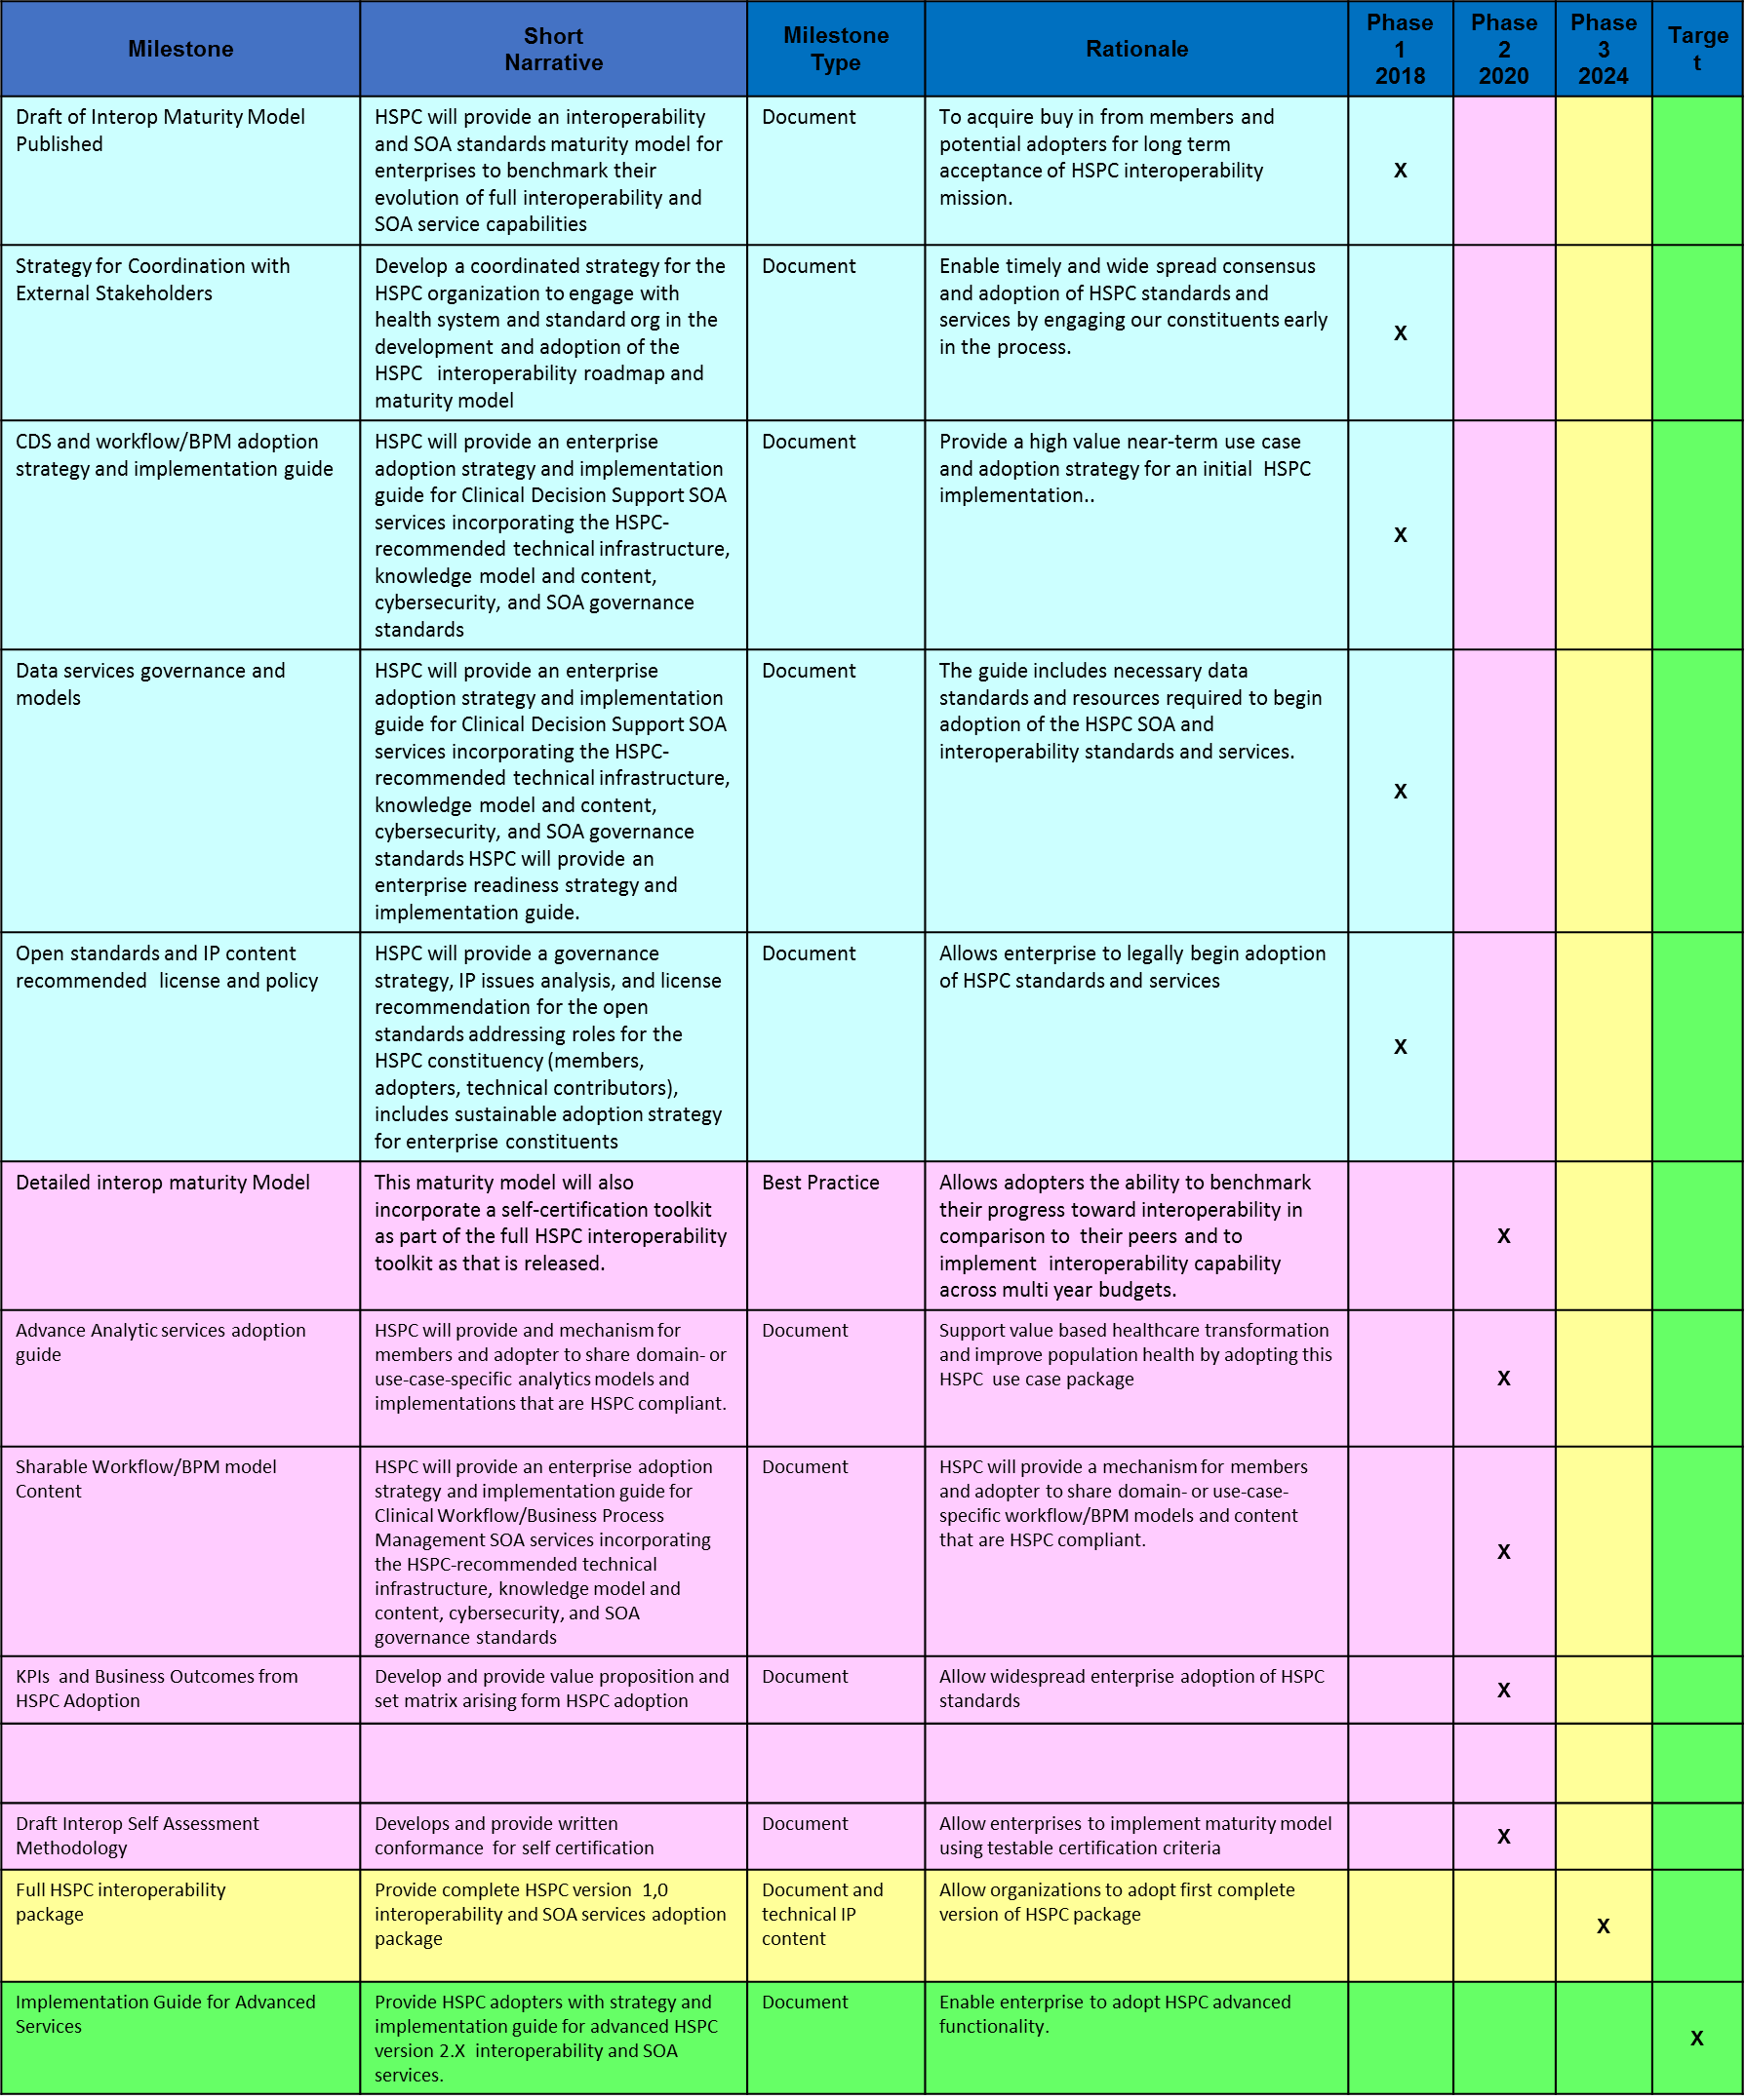

Segment/Swimlane Sections:
Segment Summary Grid:
Milestone | Phase 1 | Phase 2 | Phase 3 | Phase 4
Develop Priority Terminology Management Environment | X
Develop CIMI Model Patterns to capture expressivity of VMR, QDM, FHIR, CEM | X
Use the above to illustrate which milestones relate to which phase. For those milestones that are iteratively refined, please include all phases in which they are impacted.

Swimlane Outcomes Summary:
Capabilities Provided | Related HSPC Product(s) | Business Impact Realized
Analytics Services | - Analytics Model Sharing  - Analytics Compliance Self-Assessment | - Enhanced ability to draw inferences and comparability of data within and across healthcare organizations
Enhancement of computable model execution environments | - Publication/subscription/notification services  - ADL/AML to FHIR Services  - Artifact/Model Transformation Tools | - Ability to directly share software components and applications among healthcare EHRs and platforms.
(Milestones go here) | - (Product created/delivered) | - (Answer the “so what?”. From a business view, what benefit has been realized?)
(Milestones go here) | - (Product created/delivered) | - (Answer the “so what?”. From a business view, what benefit has been realized?)
(Milestones go here) | - (Product created/delivered) | - (Answer the “so what?”. From a business view, what benefit has been realized?)

Detail Grid:

Milestone: Knowledge Repository Specification
Overview: A Knowledge Repository (KR) is necessary in the Platform in order to contain and share knowledge artifacts. The KR Specification outlines the functions that a KR needs to support, including artifact storage capabilities, metadata requirements, artifact access services, and governance policies.
Comments: None.
Milestone Name: | (short name)
Business Value | (short description explaining the benefit of achieving this particular milestone, as seen from an organization interested in consuming the work)
Milestone Type | (Document, Software, Acceptance/Approval Milestone, etc.)
Applicable Phases | (list all the phases in which this particular milestone impacts)
Known Dependencies | (Primarily for pre-condition dependencies. Stick to the “big rocks” and don’t over-analyze).

