Task Order #9 | July 29, 2019

2004C – SDO/SRO Engagement Plan (Small/Monitor) – Media Campaign

**Solor Support Services: Solor Blog**

PRESENTED TO:

Dr. Keith Campbell & Stephanie Klepacki

IDIQ: VA701-16-D-0017

TO9 PO: 776-C80148

CLIN: 2004C – SDO/SRO Engagement Plan (Small/Monitor)

PRESENTED BY:

Team BZ

Program Manager: Jayme Welty

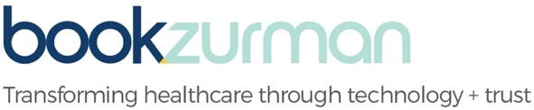

360 Central Ave., Suite 970 | St. Petersburg, FL 33701

O 727.378.9006 | bookzurman.com

**Deliverable Contents**

|  |  |  |  |
| --- | --- | --- | --- |
| **Deliverable Title** | **Description** | **File Type** | **Embedded File** |
| Solor_EHR Malpractice Blog_v0 20190725 | A blog article focusing on the cost of EHR malpractice and the importance of Solor’s interoperability capabilities | Word |  |