Blog Post
Title: How Solor can help health care organizations become HROs
Date: January 25, 2019
URL: http://solor.io/how-solor-can-help-HCOs-become-HROs

Did you know that more than 250,000 deaths in the US are attributed to medical errors every year? This is almost 7 times the number of annual automobile accident deaths. It should come as no surprise that in recent years, the US health care system has been transitioning out of a fee-for-service (FFS) model and into a value-based care (VBC) model measured by the quality and outcomes of patient care. As VBC incentives and penalties become integrated into the health care system, there exists an urgent need for a widespread standard and consistent quality of health care. With the advancement in financial, clinical, and technological cross sections of health care, health care organizations (HCOs) are experimenting with new approaches to make improvements upon their health care systems, with the safety of the patient as their top priority.

As one of the forefront players in health care, the Veterans Health Administration (VHA) is working towards becoming a High Reliability Organization (HRO) with the goal of reaching Zero Harm, i.e. not to harm patients while delivering the health care they expect. A HRO is exceptionally good at avoiding potentially disastrous scenarios and preventing catastrophic errors in an environment where accidents can be expected due a high-risk environment and complexity, all while delivering consistently safe and high-quality service. Specific examples of HROs include nuclear power plants, air traffic control systems, and chemical processing. Inspired by the effective execution of delivering safer and higher quality services of HROs, health care organizations across the US have adopted the Zero Harm ethos. Recently, VHA piloted a HRO mindset with great success at the Harry S. Truman Memorial Veterans Hospital in Columbia, Missouri by implementing high-reliability practices into the daily operations of the medical center for greater patient safety. Their 29% increase in electronic patient incident reports submitted by staff is just one example of many of their achievements as an HRO.

How can semantic interoperability lead health care organizations to become HROs?

Operational process improvement is necessary to provide more reliable care for patients. Improving operations depends on comparable and relevant health care process, cost, and outcome data. One of the biggest challenges on the path to becoming a HRO is to safely, accurately, and effectively record, transform, and use Electronic Health Records (EHRs) to the benefit of their patients, providers, and HCOs – in other words, to be semantically interoperable.

The emphasis on EHR deployment over the last ten years has created new complexity that has caused unforeseen errors, leading to real harm for patients, and challenges for providers and HCOs. Studies have shown that errors in EHRs (such as erroneous medication transcription, missing lab results, or lack of access to key treatment information) were not identified until the patient suffered moderate or severe harm due to drug overdoses, delay in critical diagnoses, or misdiagnoses leading to patient death. In one case, critical ultrasound results were routed to the incorrect display “tab” in the EHR, which led to a yearlong delay for a cancer patient to be treated.

In order for HCOs to truly function as HROs, they must first be able to overcome issues of interoperability in health care data. For example, the way clinicians record blood pressure readings electronically may differ from site to site or from department to department at the same site and within the same system. Simply put, HCOs have not identified a common standard to integrate the silos of clinical data that are spread across a multitude of EHR warehouses across the US, leading to real concerns for the future of health care.

There are three major types of interoperability in health care: foundational, structural, and semantic.

Interoperability in EHRs starts with the foundational data exchange from one system to another, where the data exchanged is stored and retrieved in a way that perhaps is as limited as storage and display of a scanned image (e.g., a fax), upon which further processing is not realistically possible. This ability to store and retrieve data received from another system provides a communication foundation upon which interoperability can be further developed.

Structural interoperability breaks up data into discrete fields with an agreed format. Examples of these fields may be a laboratory result reporting exchange, where one field may store the code for the test that was performed, and another field may store the numeric result of that test.

Semantic interoperability relies upon an ability to unambiguously process and interpret the codes and values that are exchanged within the agreed structure. Unfortunately, there is great variation in how systems encode clinical data. Frequently systems rely on locally curated terminology that must be “mapped” to an external standard—which may not contain a clinically equivalent meaning—prior to data exchange. Mapping introduces unnecessary complexity, and additional opportunities for error that can lead to patient morbidity and mortality. Interoperability by mapping, an ongoing labor-intensive, expensive, and error-prone process, is inconsistent with the principles of a HRO.

The unnecessary complexity and potential loss of information at each data transformation compromises the safety of patients, and clouds our ability to interpret that data for use by clinicians and HCOs. Solor provides a new model that can address the needs of semantic interoperability and integrate various clinical terminology standards while providing the operational necessity for local extensions of these standards in a manner consistent with the principles of a HRO.

How Can Solor Help HCOs Become HROs?

The Solor model brings together different terminology standards by using a single model that can encompass any customized content with the goal of helping health care organizations avoid errors in the interpretation of clinical data. Informaticists and developers can convert user-supplied terminologies into the single model by using open source software to produce Solor content. For example, local terminologies of patient symptoms (based on SNOMED) and lab results (based on LOINC) can be integrated using customized Solor extensions on top of existing Solor standards. Once this information is “Solorized” into the common model, both the local and native representations of clinical data can co-exist, avoiding issues of misinterpretation or missing information (see diagram below).

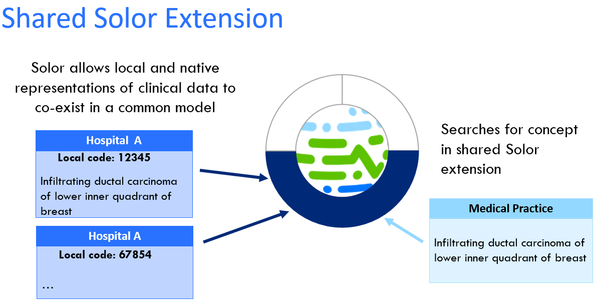

The Solor approach achieves three important functions that are key to semantic interoperability:
- Standardizes the encoded data model with the ability for additional extension models
- Enables the sharing of extensions (open and/or proprietary extensions accepted)
- Evolves existing terminology systems (SNOMED, LOINC, RxNorm, etc.) based on local needs

Health care interoperability will not happen overnight. Instead, it is an evolutionary process where by thousands of health care systems in the US will need to maintain their current systems while evolving to achieve semantic interoperability. Solor can become a new standard for this evolution by providing a consistent foundation for anyone to easily create and share customized clinical content to achieve semantic interoperability. To truly become a HRO that aims to achieve Zero Harm, we must first get the data right. Solor is definitely a step in the right direction. For a further technical understanding on how Solor works, please check out the Solor Whitepaper.

Currently the Solor team is building use cases with organizations like the FDA to address their challenges with semantic interoperability of health care data. For more information, please visit http://solor.io.

