DEPARTMENT OF VETERANS AFFAIRS
Office of Informatics and Analytics
Office of Knowledge Based Systems (KBS)

Informatics Architecture Support Services
Contract No. VA701-16-C-0157
Obligation No. 776-C60159

CLIN: 1017

SUPPORTING DOCUMENT

Task 5.5 Identify SOLOR Content that Requires Special Handling

Version 1.0

Date: January 31, 2019

Table of Contents
1. Purpose 3
2. Symmetrical Modeling Definition 3
3. Approach to Identify Content 5
4. Rules for Evaluating Membership in RefSets 8
5. Rules for Placing Concepts in the RefSets 9
6. Other Symmetry Issues 10
7. Grades, Scales, Stages and Scores 11

Table of Figures

Figure 1: Content Modeled Inappropriately (C I. above) – Concept with multiple Clinical Course attributes that have different values 6
Figure 2: Content modeled appropriately (C II. above) - Concept with multiple Associated morphology attributes and the same values 6
Figure 3. Example of Inverse Concepts modeled with radical differences – The Open subcapital facture of left femur concept is incorrectly modeled with multiple role groups while the Closed subcapital fracture of left femur is correctly modeled with a single role group 7
Figure 4. FSN contains "Acute", but does not have a Clinical Course = Acute 7
Figure 5: Grade concept with an Interprets = Procedure 11
Figure 6: Grade concept with an Interprets = Observable Entity 11
Figure 7: Grade Concept with both a Procedure and Observable Entity used for the Interprets Attribute 12
Figure 8: Grade with no Interprets Attribute 12
Figure 9. Proposed Model for Grades, Scales, Stages, and Scores Concepts 13
Figure 10. Example of Systolic heart failure stage modeled with the new concept model 14

Purpose

The purpose of the RefSets produced in the four-month extension to Option Year 1 was to identify concepts in SNOMED that are and are not symmetrical.

Symmetrical Modeling Definition

We consider modeling of concepts to be “symmetrical” if:
- Concepts which are opposites of each other (inverse concepts):
  - Exist in SNOMED and
  - Reside in the correct hierarchy under the correct parent concept

Example 1 Inverse Concepts: In this example, it is the two children concepts that are being evaluated for symmetry, not the parents.
Example 1
299331007 |Knee joint varus deformity (finding)| has two children, which are opposites. Both are present and under the correct parent concept:
- 64925008 |Acquired genu varum (disorder)|
- 79168008 |Congenital genu varum (disorder)|

Note: Inverse concepts do not necessarily have to reside under the same parent to be considered symmetrically modeled.

Example 2 Inverse Concepts: In the example below, again it is the children concepts that are being evaluated for symmetry and not the parent. In this example, the child concepts reside under different (but correct) parents.
Example 2
230763008 |Traumatic cerebral edema (disorder)| and 330011000119102 |Non-traumatic cerebral edema (disorder)| are inverse, where:
- 230763008 |Traumatic cerebral edema (disorder)| is a child of 127295002 |Traumatic brain injury (disorder)|
- 330011000119102 |Non-traumatic cerebral edema (disorder)| is a child of 2032001 |Cerebral edema (disorder)|
Further, for non-inverse concepts, we consider modeling of concepts to be “symmetrical” if:
- Concepts, which do not have more than one of the same attribute with different values in the inferred view (e.g. an attribute of clinical course with a value of acute and an attribute of clinical course with a value of chronic)
- Concepts are parent concepts of a Leaf Node and have all the correct Leaf concepts
- Concepts, which are Grades, Scales, Stages, and Scores, where all concepts exist and were consistently modeled

- Some keywords that could indicate the need for symmetry are not always reliable, for example:
  - Traumatic vs. non-traumatic - concepts without a stated “traumatic” in the FSN are considered non-traumatic by default.
  - With vs. without - not every concept that has a “with” or “without” in the FSN needs its opposite, e.g. Diagnostic arthroscopy of elbow with synovial biopsy (procedure) does not need a “…without biopsy”.

Approach to Identify Content

The below approach was used to identify the content to be reviewed to create the RefSets:

- Missing Content – Via Inverse Work
  - Inverse Refset work identified roughly 6,000 concepts that needed to be reviewed to confirm missing opposing concepts
Table 1. Example of missing opposing concepts
Conceptid | Fully Specified Name (FSN)
8587003 | Congenital diverticulum of colon (disorder)  Missing opposite: Acquired diverticulum of colon (disorder)
8656007 | Total traumatic cataract (disorder)  Missing opposite: Partial traumatic cataract (disorder)
9027003 | Normal pulmonary arterial wedge pressure (finding)  Missing opposite: Abnormal pulmonary arterial wedge pressure (finding)
21370008 | Tenotomy of abductor of hip, open (procedure)  Missing opposite: Tenotomy of abductor of hip, closed (procedure)

- Missing Content – Via Leaf Nodes
- Identify all concepts that are parents of a leaf with only one leaf (child).

- Content Modeled Inappropriately – Non-Inverse
  - Concepts that are inferred where concepts each have more than one of the same Attribute Type
  - From this set of concepts, remove any Concept that is modeled with more than one of the same Attribute Type and the same Value
  - Also remove from this set of concepts, any Concept with Attributes that are frequently used with different values, like Finding Site or Associated Morphology
  - Finally remove from this set of concepts, any Concepts from hierarchies that will not be reviewed (Products, Substances, Qualifier value, Situations, Body structures)
  - The remaining set of concepts are considered to potentially have content modeled inappropriately and should be reviewed.

Figure 1: Content Modeled Inappropriately (C I. above) – Concept with multiple Clinical Course attributes that have different values
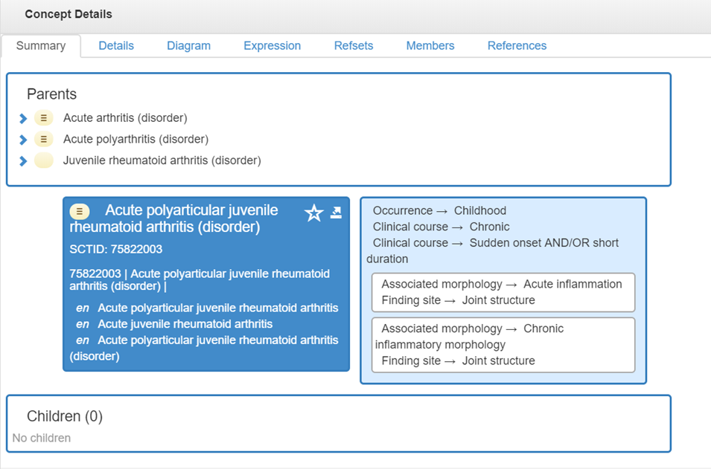

Figure 2: Content modeled appropriately (C II. above) - Concept with multiple Associated morphology attributes and the same values
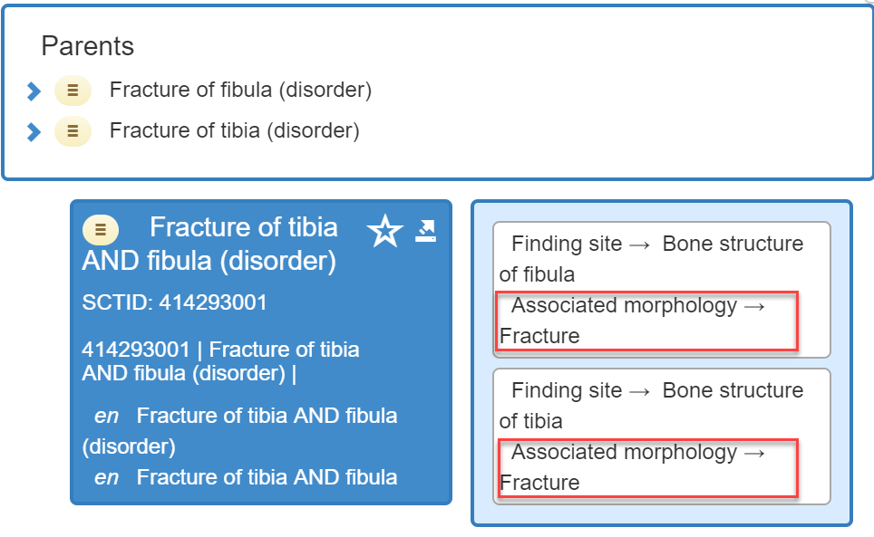

- Concept Modeled Inappropriately – Inverse
  - Using concepts that are paired as inverse of each other, we identified those concepts that are modeled differently based on querying the number of defining relationship differences. Not all of the identified modeling differences are symmetrical modeling issues but can be an indicator of them.

Figure 3. Example of Inverse Concepts modeled with radical differences – The Open subcapital facture of left femur concept is incorrectly modeled with multiple role groups while the Closed subcapital fracture of left femur is correctly modeled with a single role group
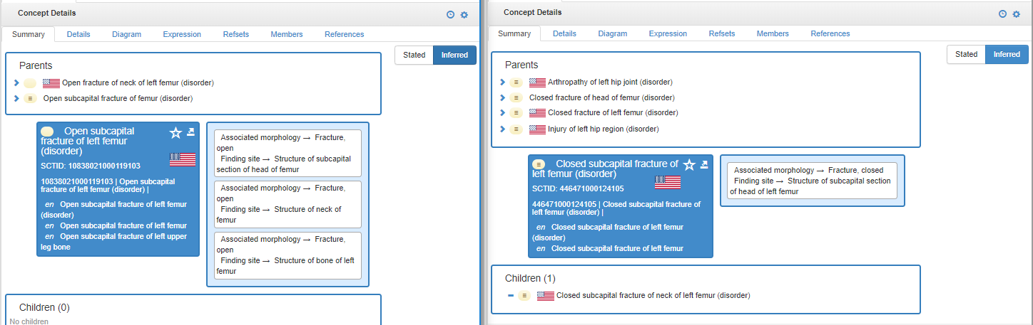

- Identify concepts that contain a common phrase without the appropriate corresponding role. This does not necessarily cause a symmetry issue as the concept may still be placed in the correct hierarchy, but can be used as a query to find a symmetry issue. If the concepts are in the appropriate hierarchy, they are considered to be symmetrical even though they are under-modeled.
  - Find all concepts that have common phrases like “Acute”, “Chronic”, “Acquired”, “Congenital” and that do not have the corresponding attribute.

Figure 4. FSN contains "Acute", but does not have a Clinical Course = Acute
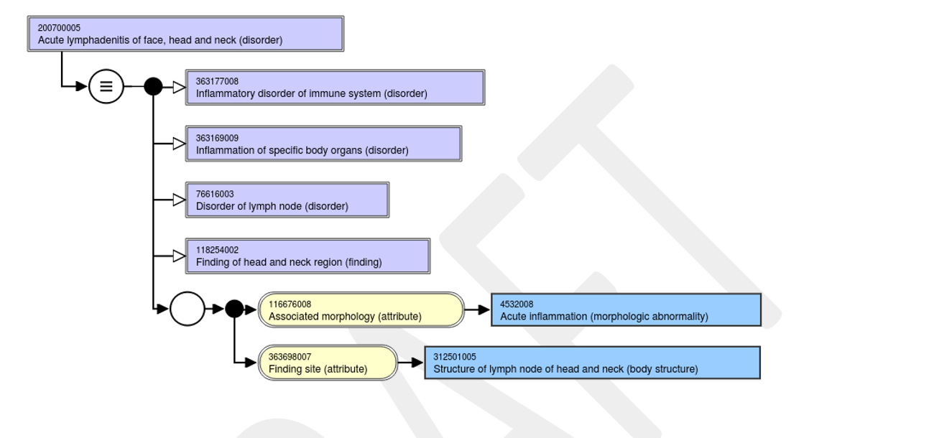

- Grades, Scales, Stages, and Scores
  - Review concepts that represent Grades, Scales, Stages and Scores to ensure all are present in the Finding and Disorder hierarchies.

Rules for Evaluating Membership in RefSets

For this project, we will deliver four RefSets that will categorize our efforts as follows:

- Symmetric Concepts
  - A simple RefSet of symmetrical child concepts that were reviewed and deemed to be in the correct hierarchy and under the correct parent.

- Non-symmetric Concepts
  - A simple RefSet of non-symmetrical child concepts that were reviewed and deemed to be placed in the wrong hierarchy (under an incorrect parent).

- Symmetric Concepts Children Present
  - A simple RefSet of parent concepts that had correct symmetric children

- Non-symmetric Concepts, Non-existent Children
  - An Annotation RefSet with parent concepts that are missing symmetrical children that should exist and any comments on what needs to be done to make them symmetrical.

Notes:

- Overlap can exist between RefSets A and C as well as between B and D. For example for RefSet A, we could have “Acquired bone deformity” and “Congenital bone deformity” as inverse child concepts, where both are children of “Bone deformity.” “Congenital bone deformity” could be a parent of a leaf node concept “Congenital deformity of femur.” Thus, that concept is a parent concept with correct symmetric children and the parent goes into RefSet C.
- RefSets A and B are mutually exclusive.
- RefSets C and D are mutually exclusive.

Rules for Placing Concepts in the RefSets

Note: For this “symmetric modeling” review, we only consider concepts “incorrectly modeled” if the incorrect modeling pertains to symmetry. If concepts have other – unrelated – modeling issues, they are not referenced as “incorrectly modeled”.

- Inverse concepts
  - If an inverse concept has an existing opposite concept and it is in the appropriate hierarchy, it was considered Symmetric Correct Modeling and placed in the “Symmetric Concepts” RefSet.

  - If an inverse concept has an existing opposite concept and it is in the wrong hierarchy, it was considered Symmetric Incorrect Modeling and placed in the “Non-Symmetric Concepts” RefSet.

- Parents of leaf concepts (concepts with only one child):

  - If the child is in the correct hierarchy and is modeled correctly, it was considered Symmetric Correct Modeling and placed in the “Symmetric Concepts Children Present” RefSet.
  - If the child does not exist or is incorrectly modeled, it was considered non-symmetric and placed in the “Non-symmetric Concepts, Non-existent Children” RefSet.

Note: “correct modeling” only applies to the correct inferred view for this concept as it pertains to symmetry. If a concept has other modeling problems, it is not marked as “incorrectly modeled”.

Other Symmetry Issues

During our review, we identified another symmetry issue, as shown below, which was out of scope for this deliverable, but could possibly be proposed to the IHTSDO as an area of content to be reviewed and edited to achieve consistency.

- Clinical Course vs. Associated Morphology

Throughout SNOMED, inconsistent modeling using attributes “clinical course” and “associated morphology” exists.

Example:

19429009 |Chronic ulcer of skin (disorder)| is modeled using 116676008 |Associated morphology (attribute)| = 405719001 |Chronic ulcer (morphologic abnormality)|

111422001 |Chronic abscess of breast (disorder)| is modeled using both the |Associated morphology (attribute)| = 79203009 |Chronic abscess (morphologic abnormality)| and the 263502005 |Clinical course (attribute)| = 90734009 |Chronic (qualifier value)|

Grades, Scales, Stages and Scores

The following analysis of the inconsistent use of Procedures and/or Observable Entities as the value of the “Interprets” Attribute is exploratory and not part of the RefSet creation.

The Findings and Disorders reviewed were found to use a Procedure 42 times vs. an Observable Entity 352 times. In 41 cases, both a Procedure and Observable Entity were used for the Interprets attribute. 400 of the concepts had no Interprets Attribute at all.

Figure 5: Grade concept with an Interprets = Procedure
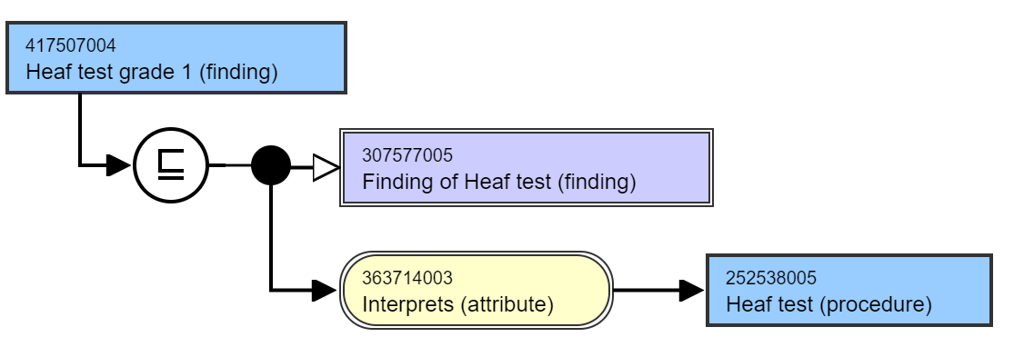

Figure 6: Grade concept with an Interprets = Observable Entity
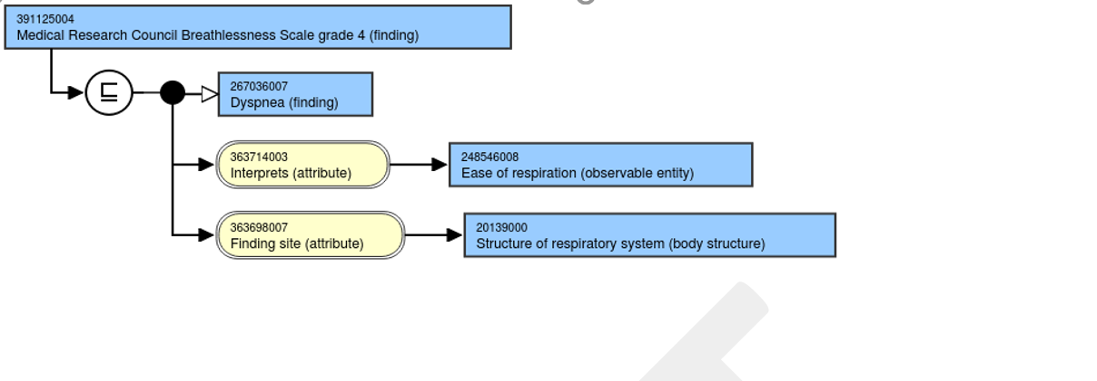

Figure 7: Grade Concept with both a Procedure and Observable Entity used for the Interprets Attribute
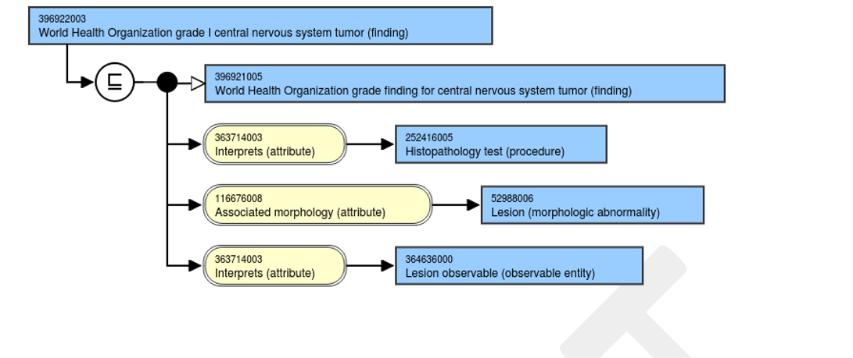

Figure 8: Grade with no Interprets Attribute
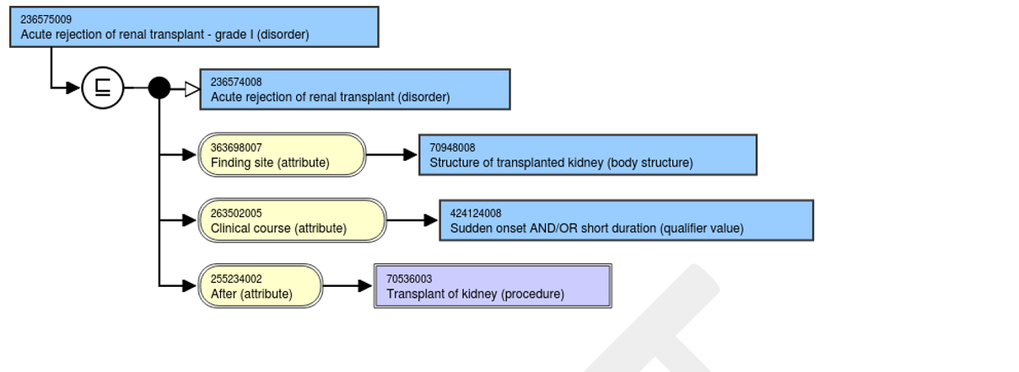

Potential Changes to Grades, Scales, Stages, and Scores Concepts

A consistent model needs to be developed and implemented to ensure Grades, Scales, Stages, and Scores concepts are symmetrical. There are many possible options available for creating a consistent concept model for Grades, Scales, Stages, and Scores but the options outlined below can be accomplished without the addition of new concept model attributes. It will require the addition of 254291000 |Staging and scales (staging scale)| as an allowable value for Interprets. A large number of Observable Entity concepts would either need to be retired or remodeled as subtypes in the Procedure hierarchy.

Figure 9. Proposed Model for Grades, Scales, Stages, and Scores Concepts
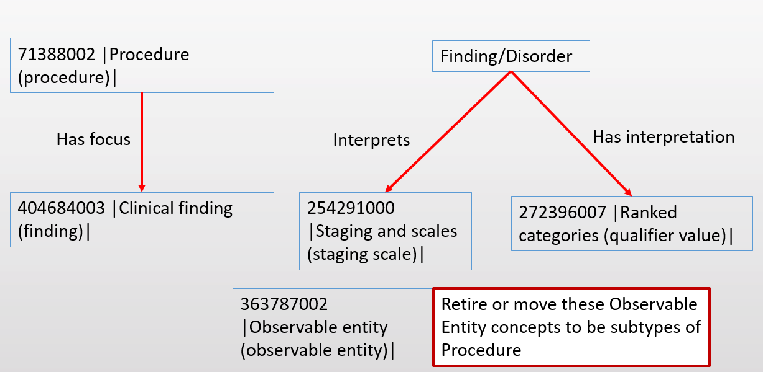

In the example below, the 120861000119102 |Systolic heart failure stage C (disorder)| concept is modeled using an Interprets to a new concept |American Heart Association (AHA) and American College of Cardiology (ACC) Stages of Heart Failure (staging scale)| and a Has interpretation to the existing concept 261626008 |Stage C (qualifier value)|. Separately, a new Procedure concept would need to be created, |Assessment using American Heart Association (AHA) and American College of Cardiology (ACC) Stages of Heart Failure (Procedure)|. Since these stages focus on the functioning of the cardiovascular system, the new procedure concepts would have a Has focus attribute that would link it to the 301458000 |Functional cardiovascular finding (finding)|.

Figure 10. Example of Systolic heart failure stage modeled with the new concept model
