DEPARTMENT OF VETERANS AFFAIRS
Office of Informatics and Analytics
Office of Knowledge Based Systems (KBS)

Informatics Architecture Support Services
Contract No. VA701-16-C-0157
Obligation No. 776-C60159

CLIN: 1017

SUPPORTING DOCUMENT

Task 5.5 Identify SOLOR Content that Requires Special Handling

Version 1.0

Date: January 31, 2019

Table of Contents
1. Purpose 3
2. Symmetrical Modeling Definition 3
3. Approach to Identify Content 5
4. Rules for Evaluating Membership in RefSets 8
5. Rules for Placing Concepts in the RefSets 9
6. Inclusion Criteria by RefSet 11
7. Other Symmetry Issues 14
8. Grades, Scales, Stages and Scores 15

Table of Figures

Figure 1: Content Modeled Inappropriately (C I. above) – Concept with multiple Clinical Course attributes that have different values 6
Figure 2: Content modeled appropriately (C II. above) - Concept with multiple Associated morphology attributes and the same values 6
Figure 3. Example of Inverse Concepts modeled with radical differences – The Open subcapital facture of left femur concept is incorrectly modeled with multiple role groups while the Closed subcapital fracture of left femur is correctly modeled with a single role group 7
Figure 4. FSN contains "Acute", but does not have a Clinical Course = Acute 7
Figure 5: Grade concept with an Interprets = Procedure 11
Figure 6: Grade concept with an Interprets = Observable Entity 11
Figure 7: Grade Concept with both a Procedure and Observable Entity used for the Interprets Attribute 12
Figure 8: Grade with no Interprets Attribute 12
Figure 9. Proposed Model for Grades, Scales, Stages, and Scores Concepts 13
Figure 10. Example of Systolic heart failure stage modeled with the new concept model 14

Purpose

The purpose of the RefSets produced in the four-month extension to Option Year 1 was to identify concepts in SNOMED that are and are not symmetrical.

Symmetrical Modeling Definition

We consider modeling of concepts to be “symmetrical” if:
- Concepts which are opposites of each other (inverse concepts):
Exist in SNOMED and
  - Reside in the correct hierarchy under the correct parent concept

Example 1 Inverse Concepts: In this example, it is the two children concepts that are being evaluated for symmetry, not the parents.
Example 1
299331007 |Knee joint varus deformity (finding)| has two children, which are opposites. Both are present and under the correct parent concept:
- 64925008 |Acquired genu varum (disorder)|
- 79168008 |Congenital genu varum (disorder)|

Note: Inverse concepts do not necessarily have to reside under the same parent to be considered symmetrically modeled.
Example 2 Inverse Concepts: In the example below, again it is the children concepts that are being evaluated for symmetry and not the parent. In this example, the child concepts reside under different (but correct) parents.

Further, for non-inverse concepts, we consider modeling of concepts to be “symmetrical” if:
Example 2
230763008 |Traumatic cerebral edema (disorder)| and 330011000119102 |Non-traumatic cerebral edema (disorder)| are inverse, where:
- 230763008 |Traumatic cerebral edema (disorder)| is a child of 127295002 |Traumatic brain injury (disorder)|
- 330011000119102 |Non-traumatic cerebral edema (disorder)| is a child of 2032001 |Cerebral edema (disorder)|
- Concepts, which do not have more than one of the same attribute with different values in the inferred view (e.g. an attribute of clinical course with a value of acute and an attribute of clinical course with a value of chronic)
- Concepts that do have more than one of the same attribute but with the same values in the inferred view.
- Concepts are Leaf Node concepts with one child and have the correct Leaf Concept children.
- Concepts, which are Grades, Scales, Stages, and Scores, where all concepts exist and were consistently modeled
Note: There can be overlap between B and D, meaning that the same concept can meet the criteria in both B and D but does not have to.

- Some keywords that could indicate the need for symmetry are not always reliable, for example:
  - Traumatic vs. non-traumatic - concepts without a stated “traumatic” in the FSN are considered non-traumatic by default.
  - With vs. without - not every concept that has a “with” or “without” in the FSN needs its opposite, e.g. Diagnostic arthroscopy of elbow with synovial biopsy (procedure) does not need a “…without biopsy”.

Approach to Identify Content

The below approach was used to identify the content to be reviewed to create the RefSets:

- Missing Content – Via Inverse Work
  - Inverse Refset work identified roughly 6,000 concepts that needed to be reviewed to confirm missing opposing concepts
Table 1. Example of missing opposing concepts
Conceptid | Fully Specified Name (FSN)
8587003 | Congenital diverticulum of colon (disorder)  Missing opposite: Acquired diverticulum of colon (disorder)
8656007 | Total traumatic cataract (disorder)  Missing opposite: Partial traumatic cataract (disorder)
9027003 | Normal pulmonary arterial wedge pressure (finding)  Missing opposite: Abnormal pulmonary arterial wedge pressure (finding)
21370008 | Tenotomy of abductor of hip, open (procedure)  Missing opposite: Tenotomy of abductor of hip, closed (procedure)

- Missing Content – Via Leaf Nodes
- Identify all concepts that are parents of a leaf with only one leaf (child).

- Content Modeled Inappropriately – Non-Inverse
  - Concepts that are inferred where concepts each have more than one of the same Attribute Type
  - From this set of concepts, remove any Concept that is modeled with more than one of the same Attribute Type and the same Value
  - Also remove from this set of concepts, any Concept with Attributes that are frequently used with different values, like Finding Site or Associated Morphology
  - Finally remove from this set of concepts, any Concepts from hierarchies that will not be reviewed (Products, Substances, Qualifier value, Situations, Body structures)
  - The remaining set of concepts are considered to potentially have content modeled inappropriately and should be reviewed.

Figure 1: Content Modeled Inappropriately (C I. above) – Concept with multiple Clinical Course attributes that have different values
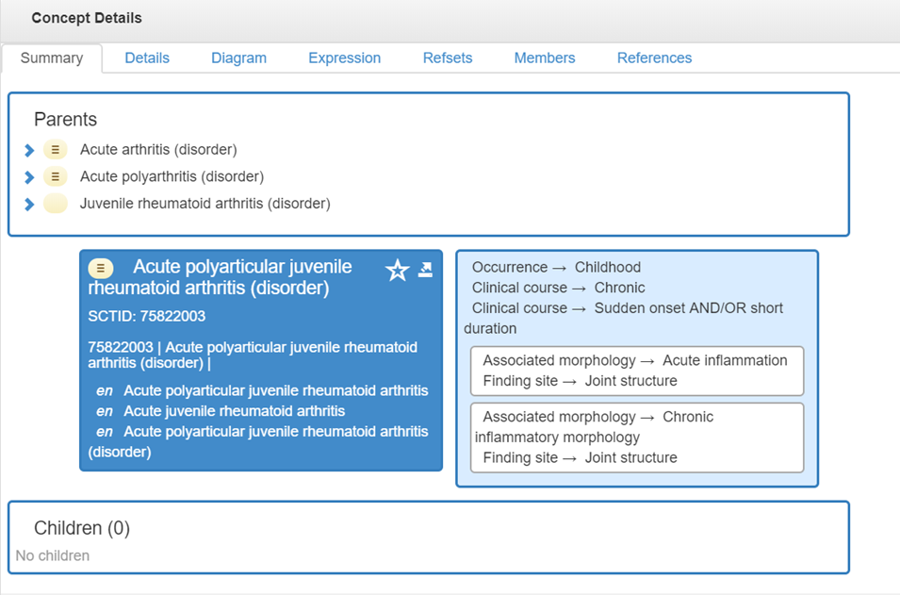

Figure 2: Content modeled appropriately (C II. above) - Concept with multiple Associated morphology attributes and the same values
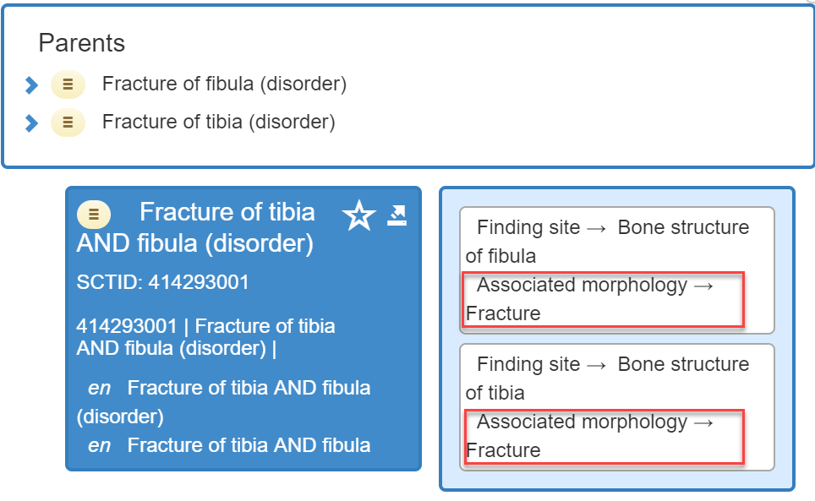
- Concept Modeled Inappropriately – Inverse
  - Using concepts that are paired as inverse of each other, we identified those concepts that are modeled differently based on querying the number of defining relationship differences. Not all of the identified modeling differences are symmetrical modeling issues but can be an indicator of them.

Figure 3. Example of Inverse Concepts modeled with radical differences – The Open subcapital facture of left femur concept is incorrectly modeled with multiple role groups while the Closed subcapital fracture of left femur is correctly modeled with a single role group
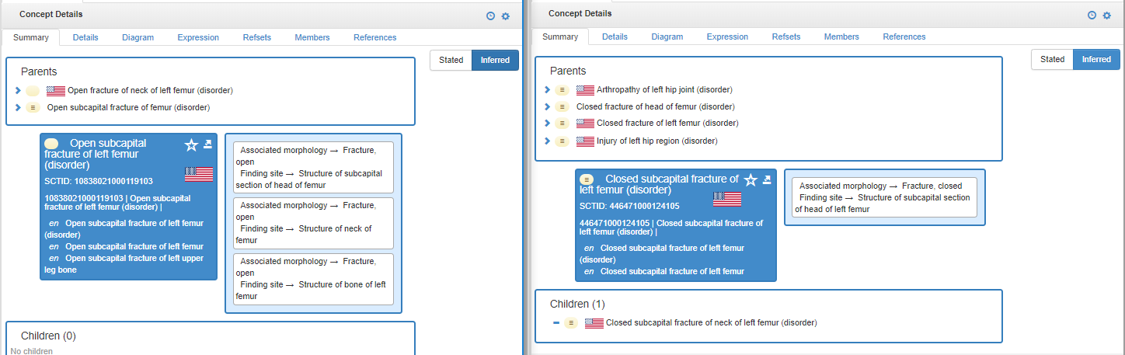

- Identify concepts that contain a common phrase without the appropriate corresponding role. This does not necessarily cause a symmetry issue as the concept may still be placed in the correct hierarchy, but can be used as a query to find a symmetry issue. If the concepts are in the appropriate hierarchy, they are considered to be symmetrical even though they are under-modeled.
  - Find all concepts that have common phrases like “Acute”, “Chronic”, “Acquired”, “Congenital” and that do not have the corresponding attribute.

Figure 4. FSN contains "Acute", but does not have a Clinical Course = Acute
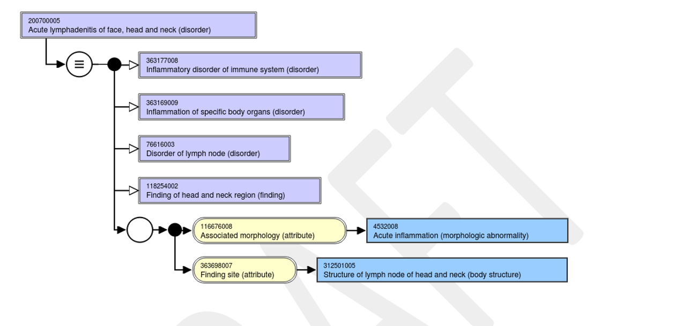

- Grades, Scales, Stages, and Scores
  - Review concepts that represent Grades, Scales, Stages and Scores to ensure all are present in the Finding and Disorder hierarchies.

Rules for Evaluating Membership in RefSets

For this project, we will deliver four RefSets that will categorize our efforts as follows:

- Symmetric Concepts
  - A simple RefSet of concepts that were reviewed and deemed to be in the correct hierarchy and correctly modeled. This includes inverse concepts.

- Non-symmetric Concepts
  - A simple RefSet of concepts that were reviewed and deemed to be placed in the wrong hierarchy (under an incorrect parent). This includes inverse concepts.

- Symmetric Concepts Children Present
  - A simple RefSet of parent concepts that had correct children

- Non-symmetric Concepts, Non-existent Children
  - An Annotation RefSet with parent concepts that are missing symmetrical children that should exist and any comments on what needs to be done to make them symmetrical.

Notes:

- Overlap can exist between RefSets A and C as well as between B and D. For example for RefSet A, we could have “Acquired bone deformity” and “Congenital bone deformity” as inverse child concepts, where both are children of “Bone deformity.” “Congenital bone deformity” could be a leaf node concept with one child: “Congenital deformity of femur.” Thus, that concept is a parent concept with correct symmetric child and the parent goes into RefSet C.
- RefSets A and B are mutually exclusive.
- RefSets C and D are mutually exclusive.

Rules for Placing Concepts in the RefSets

Note: For this “symmetric modeling” review, we only consider concepts “incorrectly modeled” if the incorrect modeling pertains to symmetry. If concepts have other – unrelated – modeling issues, they are not referenced as “incorrectly modeled”.
Inverse concepts
  - If an inverse concept has an existing opposite concept and it is in the appropriate hierarchy, it was considered Symmetric Correct Modeling and placed in the “Symmetric Concepts” RefSet.

  - If the child is an inverse concept, where its opposite would be included under a different parent but the opposite does not exist or the concept is incorrectly modeled, it was considered Symmetric Incorrect Modeling and placed in the “Non-Symmetric Concepts” RefSet.

Parents of leaf concepts (concepts with only one child):

  - If the child is in the correct hierarchy and is modeled correctly, it was considered Symmetric Correct Modeling and placed in the “Symmetric Concepts Children Present” RefSet.
  - If the child is an inverse concept and its opposite does not exist or the concept is incorrectly modeled, it was considered non-symmetric and placed in the “Non-symmetric Concepts, Non-existent Children” RefSet.

Note: “correct modeling” only applies to the correct inferred view for this concept as it pertains to symmetry. If a concept has other modeling problems, it is not marked as “incorrectly modeled”.

Inclusion Criteria by RefSet

- Symmetric Concepts RefSet

Concept Type | Rule | Symmetrical | Example | Comment
Inverse Concepts  - Can be parents of leaf concepts  - Can be children of leaf node concepts | Opposite exists AND resides in correct hierarchy |  | 371350001 |Tolerance related finding (finding)|  Is parent of  102460003 |Decreased tolerance (finding)|  102459008 |Increased tolerance (finding)| | Since inverse concepts can be parents of leaf concepts, concepts in this RefSet can also appear in RefSet C (Symmetric Concepts Children Present)
Non-inverse concepts  - Can be parents of leaf concepts  - Can be children of leaf concepts | Concepts do NOT have more than one of the same attribute with DIFFERENT values in the inferred view | * | 110960005 |Ureter cytologic material (specimen)|  has one child that is not inverse and does not require an opposite | *Concepts, which fit this rule will be in the “SymmetricConcepts” RefSet, unless they have other modeling issues that pertain to symmetry
 | Concepts DO have more than one of the same attribute, but with the SAME values in the inferred view | * | 414293001 |Fracture of tibia AND fibula (disorder)|  116676008 |Associated morphology (attribute)| - 72704001 |Fracture (morphologic abnormality)| occurs twice: one for tibia, one for fibula. Correctly modeled in separate Role Groups.
 | Concepts are correctly modeled and in the correct hierarchy |  | 306963008 |Choanal stenosis (disorder)|  Is parent of  34821005 |Congenital stenosis of choanae (disorder)|
Grades, Scales, Stages, and Scores  - Can be inverse concepts  - Can be non-inverse concepts | All concepts exist AND are consistently modeled |  | 446766005 |Assessment using arthritis impact measurement scale (procedure)|  304708005 |Arthritis impact measurement scale (assessment scale)|  446478005 |Arthritis impact measurement scale score (observable entity)|

- Nonsymmetric Concepts RefSet

Concept Type | Rule | Symmetrical | Example | Comment
Inverse Concepts  - Can be parents of leaf concepts  - Can be children of leaf concepts | Opposite does not exist OR resides in wrong hierarchy |  | 432734004 |Congenital asymmetry of breasts (finding)|  Opposite Acquired asymmetry of breasts does not exist | Since inverse concepts can be parents of leaf concepts, concepts in this RefSet can also appear in RefSet D (NonsymmetricConcepts Non-Existing Children)
 | Concepts, where the opposites are modeled radically different |  | 102461004 |Increased intolerance (finding)| vs.  102462006 |Decreased intolerance (finding)|  “Increased” is modeled only with an “interprets” attribute and a “General clinical state” value;  “Decreased” is modeled with the same attribute, but additionally with an “interprets” attribute and a “intolerance, function” value and a “has interpretation” attribute with a “decreased” value.
Non-inverse concepts  - Can be parents of leaf concepts  - Can be children of leaf concepts | Concepts DO have more than one of the same attribute with DIFFERENT values in the inferred view |  | 16024431000119108 |Acute polyarticular juvenile idiopathic arthritis (disorder)| has 2 “clinical course” attributes, one with a “chronic” and one with a “sudden onset and/or short duration” value.
Grades, Scales, Stages, and Scores  - Can be inverse concepts  - Can be non-inverse concepts | Not all concepts exist OR are consistently modeled |  | 396922003 |World Health Organization grade I central nervous system tumor (finding)| has 2 “interprets” attributes with different values

- Symmetric Concepts Children Present RefSet

Concept Type | Rule | Symmetrical | Example | Comment
Parents of Leaf Concepts  - Can be inverse concepts  - Can be non-inverse concepts | Children are in the correct hierarchy AND no children missing |  | 168555002 |Plain X-ray skull normal (finding)|  Has child: 168562006 |Plain X-ray nose normal (finding)|, which is inverse.  Its opposite 168563001 |Plain X-ray nose abnormal (finding)| exists and is in correct hierarchy | Since parents of leaf concepts can be inverse concepts, concepts in this RefSet can also appear in RefSet A (SymmetricConcepts)

- Nonsymmetric Concepts Non-Existing Children RefSet

Concept Type | Rule | Symmetrical | Example | Comment
Parents of Leaf Concepts  - Can be inverse concepts  - Can be non-inverse concepts | Children are missing |  | 237784000 |Adrenal cyst (disorder)|  Has child: 205744006 |Congenital cyst of adrenal gland (disorder)|, which is inverse. Its opposite “Acquired cyst of adrenal gland” is not present. | Since parents of leaf concepts can be inverse concepts, concepts in this RefSet can also appear in RefSet B (NonsymmetricConcepts)

Other Symmetry Issues

During our review, we identified another symmetry issue, as shown below, which was out of scope for this deliverable, but could possibly be proposed to the IHTSDO as an area of content to be reviewed and edited to achieve consistency.

- Clinical Course vs. Associated Morphology

Throughout SNOMED, inconsistent modeling using attributes “clinical course” and “associated morphology” exists.

Example:

19429009 |Chronic ulcer of skin (disorder)| is modeled using 116676008 |Associated morphology (attribute)| = 405719001 |Chronic ulcer (morphologic abnormality)|

111422001 |Chronic abscess of breast (disorder)| is modeled using both the |Associated morphology (attribute)| = 79203009 |Chronic abscess (morphologic abnormality)| and the 263502005 |Clinical course (attribute)| = 90734009 |Chronic (qualifier value)|

Grades, Scales, Stages and Scores

The following analysis of the inconsistent use of Procedures and/or Observable Entities as the value of the “Interprets” Attribute is exploratory and not part of the RefSet creation.

The Findings and Disorders reviewed were found to use a Procedure 42 times vs. an Observable Entity 352 times. In 41 cases, both a Procedure and Observable Entity were used for the Interprets attribute. 400 of the concepts had no Interprets Attribute at all.

Figure 5: Grade concept with an Interprets = Procedure
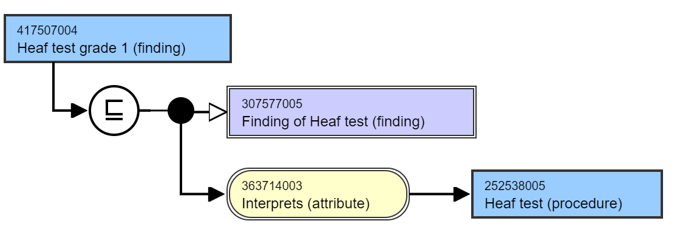

Figure 6: Grade concept with an Interprets = Observable Entity
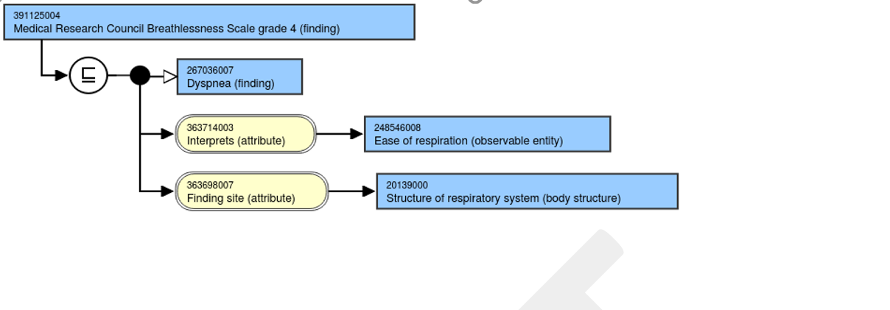

Figure 7: Grade Concept with both a Procedure and Observable Entity used for the Interprets Attribute
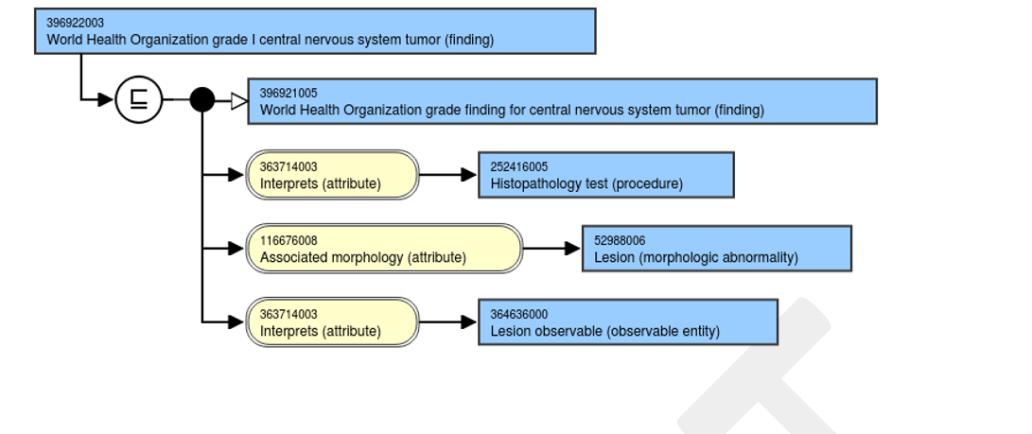

Figure 8: Grade with no Interprets Attribute
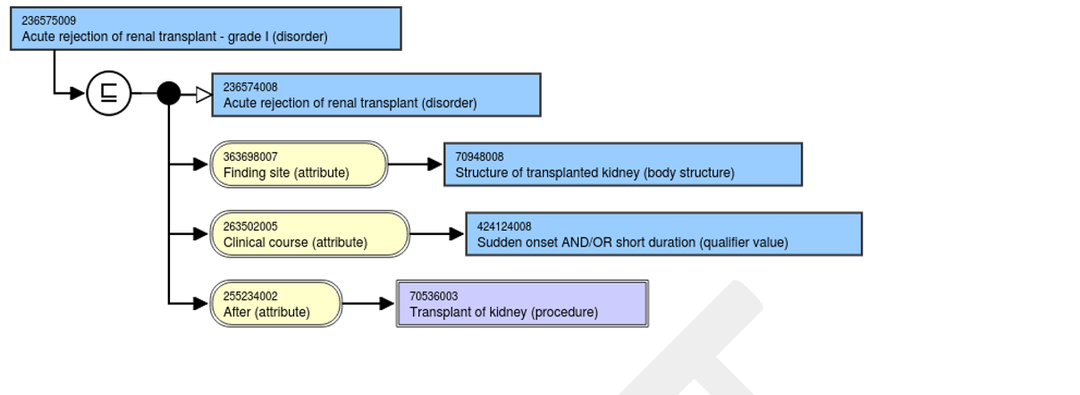

Potential Changes to Grades, Scales, Stages, and Scores Concepts

A consistent model needs to be developed and implemented to ensure Grades, Scales, Stages, and Scores concepts are symmetrical. There are many possible options available for creating a consistent concept model for Grades, Scales, Stages, and Scores but the options outlined below can be accomplished without the addition of new concept model attributes. It will require the addition of 254291000 |Staging and scales (staging scale)| as an allowable value for Interprets. A large number of Observable Entity concepts would either need to be retired or remodeled as subtypes in the Procedure hierarchy.

Figure 9. Proposed Model for Grades, Scales, Stages, and Scores Concepts
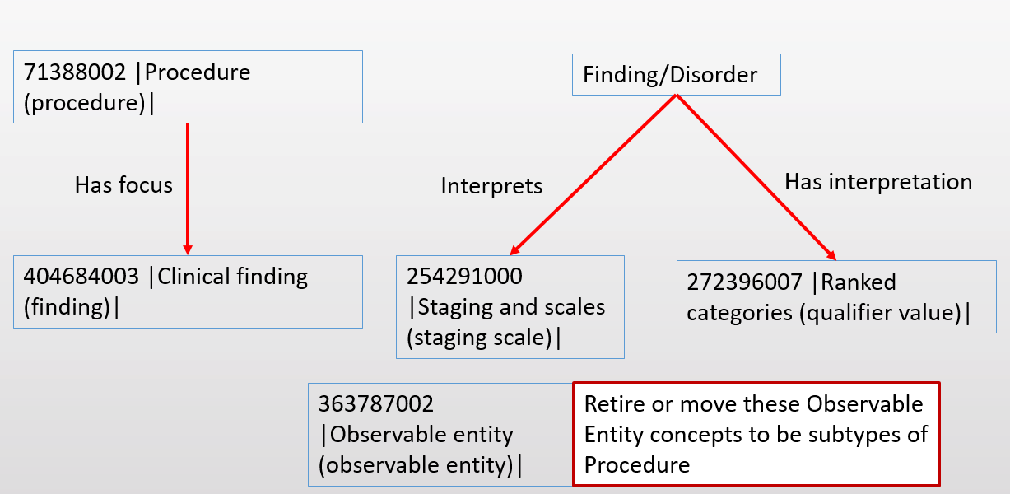

In the example below, the 120861000119102 |Systolic heart failure stage C (disorder)| concept is modeled using an Interprets to a new concept |American Heart Association (AHA) and American College of Cardiology (ACC) Stages of Heart Failure (staging scale)| and a Has interpretation to the existing concept 261626008 |Stage C (qualifier value)|. Separately, a new Procedure concept would need to be created, |Assessment using American Heart Association (AHA) and American College of Cardiology (ACC) Stages of Heart Failure (Procedure)|. Since these stages focus on the functioning of the cardiovascular system, the new procedure concepts would have a Has focus attribute that would link it to the 301458000 |Functional cardiovascular finding (finding)|.

Figure 10. Example of Systolic heart failure stage modeled with the new concept model
