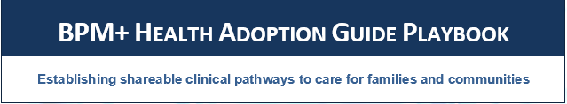
==

This page is intentionally blank.
Table of Contents
Executive Summary 5
1 Introduction to Guide 6
2 Value Proposition 7
2.1 Value from a Clinical Perspective 7
2.2 Value from a Technical Perspective 7
3 Adoption Readiness Assessment/Maturity Model 8
3.1 Value Proposition - Why Use a Maturity Model 8
3.2 How to Use the RAMM for Organizational Assessment 12
3.2.1 Perform the assessment 12
3.2.2 Checkpoint Assessment 12
3.2.3 Formal Assessment 13
4 Stakeholders 14
4.1 Organizations 14
4.2 Individuals 14
4.2.1 Executives and managers 14
4.2.2 Terminologists/Standards Developers and Users 14
4.2.3 Modelers 14
4.2.4 Developers/IT Staff 15
4.2.5 Implementers 15
4.2.6 Health Care Team members 15
4.2.7 Performance Improvement/Quality Specialists 15
4.2.8 Data Analytics Staff 15
5 Adopting Clinical Practice Guidelines 16
5.1 Engagement for success 16
5.2 Uses Cases(s)—Overarching 17
5.2.1 Attributes for Selection of An Organizational Use Case 17
5.3 Engagement for success 18
5.4 Secure Organizational Commitment 19
5.5 Readiness assessment 19
5.5.1 Institutional Standards/Guidelines/Policies 19
5.5.2 Stakeholder Management 19
5.5.3 Knowledge Management/Tools/Automation 19
5.5.4 Privacy/Security/Legal Considerations 19
5.5.5 Human Skills and Expertise 20
5.5.6 Goals and Measurement 20
5.6 Develop Organizational Change Management: Strategy and Implementation 20
5.7 Pilot Implementation, Assessment, and Modification 20
5.7.1 Organize and Prepare 20
5.7.2 Test and Modify 21
5.7.3 Enterprise Deployment 22
6 Evaluation/Metrics 22
6.1 Measuring New Pathway Processes 22
6.2 Measuring Impact and Outcomes 23
6.3 Measuring the Adoption Process 23
7 Lessons Learned 24
Appendix 25
References 26

BPM+ Health Adoption Guide Playbook

Executive Summary
This BPM+ Health Adoption Playbook proposes an adoption and change management process for organizations seeking to translate sharable clinical pathways directly into local clinical processes and workflows. The playbook is designed to go beyond the technical aspects of clinical pathway implementation; it focuses on the management, people, process, and acquisition components of the undertaking. It is important to note that adoption of sharable clinical pathways does not necessarily imply full automation. Adoption may range from using the pathways as specifications for the reengineering of manual processes all the way to full process automation. The principles and approaches outlined in this document apply to the full spectrum of adoption.
BPM+ Health Adoption Guide Playbook

Introduction to Guide
The Business Process Management Plus Health (BPM+ Health) community of the Object Management Group (OMG) is a community of practice based upon the use of open, standards-based notations which allow for all types of health organizations, professional societies, and vendors to document their care pathways and workflows so that they are sharable, discoverable, and in the future can be computer-consumable (computable). This approach results in guidelines that have been demonstrated to be more accurately expressed, more internally consistent, and more consumable than paper or pdf-style counterparts.
This BPM+ Health Adoption Playbook is offered as a companion to the OMG Healthcare Domain Task Force’s Field Guide to Shareable Clinical Pathways and provides guidance and tools to assist organizations with the adoption of shareable clinical pathways to continuously improve quality and efficiency of care. The Playbook goes beyond the mechanics of model localization that may be needed for a specific setting of care and addresses the variety of organizational business capabilities needed to support multiple levels of adoption: documentation, specification, computation, and execution.
Guiding Principles
The following principles should guide the adoption of sharable clinical pathways :
- Take a holistic perspective ( system and people who use the system)
- Communicate transparently, inclusively and openly
- Maintain the integrity (clinical intent) of the pathway
- Incorporate of human centered design principles (caregivers, patients)
- Commit to continuous improvement and innovation to improve patient outcomes
- Ensure that processes and solutions are trustworthy (security, privacy, etc)
- Make ethically grounded decisions
- Ensure equity
- Support and complement clinical judgement
- Foster standardization across institutions

Value Proposition
The creation and dissemination of medical knowledge is foundational to the delivery of high-value health care. But the pace of discovery has accelerated to a point where it is no longer possible for caregivers to keep up with the latest diagnostic and treatment approaches. Professional societies, academic medical centers and medical knowledge vendors work to synthesize and publish new knowledge, but adoption of best practices and application of new knowledge to practice remains a challenge.
At the same time, there has been a rapid advancement in the use of health care information technology (HIT). This technology has great potential to improve the quality and efficiency of care, but at the same time, introduces new opportunities for miscommunication and medical errors.
The BPM+ standards offer a way to bridge the gap between rapidly advancing medical knowledge and increasingly complex and sophisticated HIT by creating pathways that are understandable by medical professionals and can be easily and reliably implemented in HIT solutions.
What is the Role of BPM+ in Clinical Care?
For many years, those in the health care domain struggled to leverage technology to manage and optimize clinical workflows. Several domain-specific representation languages have been offered up but none has achieved wide adoption. The BPM+ Health community grew out of an interest in evaluating the fitness of the OMG business process modeling language for health care. The BPM+ family of process modeling languages has been used successfully in a wide variety of business domains to model and manage processes, decision-making, and case management. Multiple organizations have demonstrated that the BPM+ languages can be combined with clinical semantics to faithfully represent clinical workflows.

2.1 Value from a Clinical Perspective
The flood of new medical knowledge makes it difficult, if not impossible, for practicing clinicians to stay current on advances in health care. Clinical guidelines synthesize new knowledge and offer evidence-based recommendations, but the guidelines are often dense and make it difficult to rapidly find answers to clinical questions. BPM+ offers a way to formally and unambiguously represent the knowledge from clinical guidelines, and to translate that knowledge directly into clinical processes and workflows, making it easy to do the right thing.

2.2 Value from a Technical Perspective
Health information technology provides an opportunity to develop and configure clinical applications to support best practices. However, clinical knowledge is often “hard-coded” into solutions, an approach that is labor-intensive and creates significant technical debt. The effort needed to translate guidelines into code requires a significant commitment of IT staff, an effort that must be repeated at each organization. And once implemented, organizations struggle to understand what knowledge is embedded where, and to keep the knowledge current and consistent. BPM+ is a relatively mature set of standards which are supported by multiple vendors who offer editing and execution tools, significantly reducing the effort of implementation.

Adoption Readiness Assessment/Maturity Model
The Adoption Readiness Assessment and Maturity Model (RAMM) for sharable clinical pathways is intended to evaluate the maturity of an organization's capacity to adopt clinical guidelines, not the maturity of its clinical practice. The RAMM consists of five maturity levels, each representing a more advanced plateau in adopting and improving the use of clinical pathway technology and supporting processes. The RAMM is underpinned by a model of organizational development that has proven successful in other industries for improving the quality, cost, and productivity of outcomes, as well as providing a foundation for automation.

3.1 Value Proposition - Why Use a Maturity Model
Seventy percent of best practice and improvement programs fail either in their initial attempt to improve operations or in their inability to sustain improved practices. Capability Maturity Models were designed to help organizations steadily eliminate the barriers to improvement and adopt improved practices and supporting technology through a disciplined, sustainable, evolutionary path. Maturity Models have two primary uses: process evaluation and an organizational improvement roadmap.
The first use, process evaluation, assesses the level of capability with which different processes have been implemented in an organization. Each process (or cluster of related processes) is typically rated on a scale of 1 to 5 based on the way it has been implemented and its effectiveness. The value of using a maturity model for evaluation is in providing an organization with a standardized assessment of the current state of each process from which it can make decisions about where to make improvements.

Figure 1: RAMM Maturity Levels
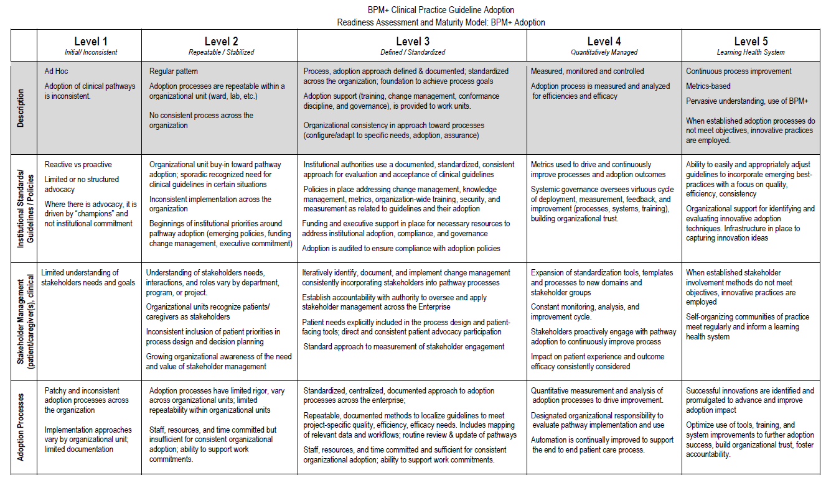

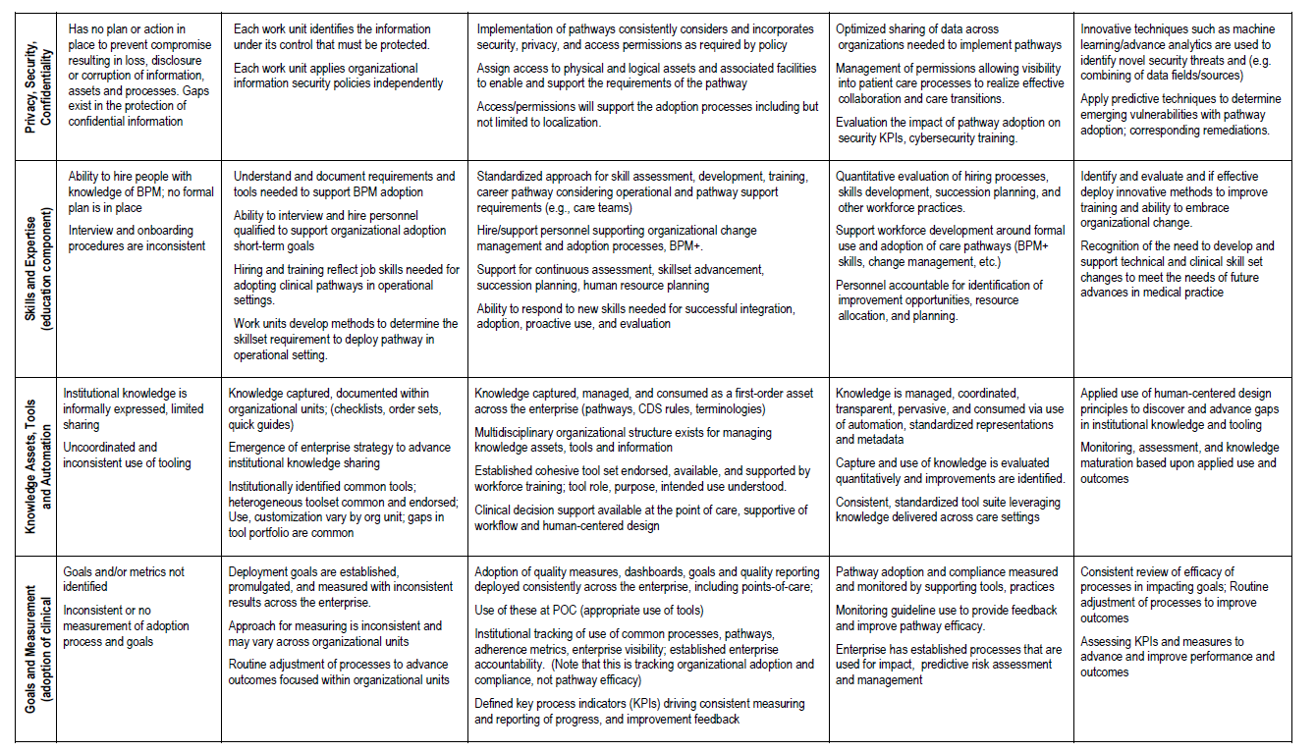

The second and more powerful use of maturity models is in providing an organizationally-based roadmap for continually improving and sustaining an organization’s processes and technologies. Maturity models designed for this purpose provide guidance for people, processes, and technologies that help establish a new plateau of organizational effectiveness at each maturity level. The evolutionary trajectory of these organizationally-based maturity models are defined as Level 1–Initial, Level 2–Stabilize, Level 3–Standardize, Level 4–Optimize, and Level 5–Innovate. Such maturity models have guided evidence-based improvement in organizational effectiveness and productivity in industries such as system development, workforce development, banking, and hospitality.
The RAMM can guide health care organizations to adopt and sustain clinical pathways and their supporting technologies with greater success. Many health care organizations are at initial maturity Level 1 where management and work practices are inconsistent across the organization and operations in some areas are occasionally ad hoc. There can be numerous barriers to improvement such as work overload, lack of resources, poorly defined processes, lack of training, and other conditions that degrade performance. Clinical results in these facilities are typically below industry norms. There may even be resistance to improved practices. Without removing these barriers to improvement, the adoption of clinical pathways and supporting technology will be spotty at best.
Level 2 improvements stabilize basic work processes within work units and establish control over the most egregious barriers to improvement. Level 2 improvements establish management control over the conditions that hinder improvement. However, a Level 2 capability does not require that all processes be standardized across work units, but rather that the processes used within a work unit are repeatable. Once stable, work units are capable of adopting and sustaining standard practices, while work units suffering unstable conditions constantly defer adoption to fight fires. Stable Level 2 clinical environments are characterized by fewer mistakes and more efficient staff.
Level 3 improvements involve adopting standardized best clinical pathways and supporting technology across the organization, creating an integrated end-to-end set of clinical pathways and supporting processes. Clinical pathways constitute a CPMM Level 3 process with tailoring guidelines for how patients present and decision points for guiding care. Level 3 standardization builds consistent processes in work units with similar functions and defined interfaces to other units that enable simpler, more integrated automation across the course of a patient’s care from admission to release. The end-to-end treatment process is instrumented with measures to support continual improvement and establish a learning environment. This standardization establishes an economy of scale that enables consistent performance as the size of the organization or caseload grows.
Level 4 involves improvements for optimizing the performance of standard clinical practices by implementing lean, Six Sigma, statistical management, reusable assets, integrated end-to-end process automation, self-managed teams, and other means for optimizing the effectiveness of clinical pathways and the performance of standard processes and technologies. Standard processes are a required foundation for techniques such as lean and six sigma that provide a foundation for continual improvement, since standard practices remove many sources of extraneous variation in performance.
Level 5 improvements involve innovating where optimized standard practices and processes were not adequate to meet clinical, patient, or organizational outcomes. The innovations can involve improved technology, processes, information transfer, training, care guidelines, and outcome prediction. Innovations can be tested empirically, and if sufficiently beneficial, can be integrated into standard processes and technology, and then optimized. The CPMM’s improvement roadmap provides the organizational development and change management foundation that underlies the success of the original Capability Maturity Models.

3.2 How to Use the RAMM for Organizational Assessment

3.2.1 Perform the assessment
The RAMM has two primary uses:
- Structuring the assessment of a healthcare facility’s adoption practices
- Guiding the adoption of improved clinical practices
The findings of an assessment should be turned into improvement plans based on the current maturity level achieved by the organization and the gaps in its practices at the next higher level. Only under exceptional conditions should an organization attempt to implement practices two maturity levels higher than the current level of an organizational factor. This general rule recognizes that the foundation laid at the next maturity level is usually necessary for implementing and sustaining practices two levels up or higher. When foundation is not in place, the risk of an ineffective implementation is much higher. However, once the foundational practices are in place, implementation of higher-level practices has a high probability of success.
This section elaborates the mechanisms for performing the Readiness Assessment prescribed in Section 4.3. The RAMM provides the content for an assessment in a form that structures the collection of data. There are two primary categories of assessment methods: checkpoint and formal. Unless a formal result is needed for such purposes as a certification, most organizations will opt for one of the less intensive checkpoint methods.

3.2.2 Checkpoint Assessment
The purpose of a checkpoint assessment is to develop a rapid understanding of an organization’s readiness for adopting automated clinical pathways. Checkpoint assessments are less formal, time-consuming, and expensive than the formal assessment described in section 5.2.3. Nevertheless, checkpoint assessments require planning, question preparation, and communication prior to their implementation. There are two approaches to checkpoint assessments: questionnaires and interviews. They will be discussed separately, although they can be combined.
1. Questionnaires: Well-constructed questionnaires can be administered to department leads and some senior practitioners to get an overview of how the current state of an organization’s practices is perceived. Questionnaires should be carefully developed to cover each of the organizational factors listed in Section 4.3. Questions should be keyed to the anticipated current level of readiness and all levels below it, plus one level above. Questionnaires can be administered individually, in group sessions, or online, whichever is least disruptive. The purpose and schedule of the questionnaire administration should be communicated to the affected staff. The team administering the questionnaires should be available for questions while questionnaires are being completed. The team can also hold follow-up discussions to clarify findings. The results are anonymized and submitted to the improvement team to guide their interventions. While questionnaires can be an efficient way to collect data, there are potential biases in the results that must be considered.
2. Interviews: One of the most effective methods for gathering readiness data is through conducting small team interviews with senior people in each affected department, either separately or in small groups. Schedules should be developed to minimize disruption and communicated early. The interviews should be conducted by two people so that one can focus on asking questions and guiding the interview, while the other focuses on taking notes. The questions should be prepared as described for questionnaires. However, since the answers are open-ended they allow for flexibility in follow-ups and clarifications. Each interview should be scheduled for an hour or less. Depending on the number of interviews, the assessment can take from one to several days. The interview team should allow enough time each day to consolidate their findings and adjust the questions for subsequent interviews. When interviews are completed, the team organizes their findings into a report that is provided to the organization and the improvement team.

3.2.3 Formal Assessment
The purpose of a formal assessment is to provide an externally credible measure of the maturity of an organization’s practices for adopting clinical pathways. Even if the result is not shared externally, it provides a thorough and defensible analysis of the organization’s current practices that can be used to guide improvements. Consequently, this category of assessment employs more rigor in its planning and conduct, and consumes more resources. The phases of conducting a formal assessment include:
1. Preparation Phase: The launch of a formal assessment needs visible support from the executive level. The planning begins with identifying the scope of the assessment and the work units in the organization to be assessed. Those selected for the assessment team must be trained in both the RAMM and assessment process. Some members of the assessment team should come from the organizational units assessed in order to carry first-hand knowledge of the observations back into their units. The plan should include a schedule for both reviewing practice-related documents, conducting practitioner interviews in the selected units, and analyzing and presenting results. A formal assessment can take from several days to a week depending on the size of the organization and the scope of the assessment coverage.
2. Assessment Phase: The assessment should be launched with a presentation to those involved about the purpose and schedule of the assessment as well as a promise of anonymity. Heads of the selected units should be interviewed separately from those working in the unit, some or all of whom may be interviewed as a group. Time should be reserved each day to summarize the findings of the document reviews and interviews aggregated to that point.
3. Results and Improvement Phase: The assessment team develops their consensus findings on each of the organizational factors listed in section 4.3 and presents their findings to the organization in a written assessment report and in a meeting. The report is then handed to the improvement team leading the adoption of automated clinical pathways to develop their improvement plan based on the findings in the assessment report. There should be some overlap in members between the assessment and improvement teams.

Stakeholders
The following roles would be the target audience for some or all parts of this playbook. This section helps identify the roles or the functions that you may consider to have on your team.

4.1 Organizations
Organizations reflect their missions as well as their members and have their own considerations in the process of change. Commitments to adopt new capabilities, in this case the BPM+ suite of models and tools, impact most if not all of an organization and the second order effects need to be anticipated and monitored in response to change. Departments such as primary care, general surgery and all specialty, medical/surgical, administrative, human resources, legal, security, risk management, and quality improvement among others can all be positively or negatively impacted. The size and mission of the organization also shapes its role as a stakeholder to consider in the adoption and implementation process.

4.2 Individuals
The initiative leaders, requisite skill sets, qualified personnel, change agents and others identified through studying successful implementations need to be identified and in place at the appropriate time for the various stages of implementation.

4.2.1 Executives and managers
Executives at the appropriate level need to be identified and charged with leading and sponsoring adoption (securing a realistic budget, funding it and addressing any changes that occur over time). In addition, identify competent managers that will take their scope of the project through the process of adoption, receiving any prior work and handing off any subsequent work with overlap at both ends and a sustainment plan for the future.

4.2.2 Terminologists/Standards Developers and Users
Make sure to staff the adoption with the appropriate technical personnel (terminologists, standards experts) and include the user community in the approach, change management, training, sustainment, optimization and ongoing feedback to support each stage of adoption, implementation and sustainment. While not absolutely necessary, larger organizations should have representation in standards development and ideally organic staff who actually are engaged in the development of the standards being adopted.

4.2.3 Modelers
Once an organization is committed to adopting BPM+, it is important to have a hand in the modeling process to understand how it is done and to be able to model for your organization’s implementation needs over time. Planning for an adequate number of modeling staff positions or contracting for modelers to assist with your implementation and sustainment over time will add to adoption success.

4.2.4 Developers/IT Staff
Developers (architects, security; team components), are another integral part of an adoption effort; the make/buy decision (on the payroll or contracted as needed) needs to be part of the planning process for long term adoption of the BPM+ standards. IT support is required throughout the lifecycle of: implementation, use (operations), optimization to replacement and retirement.

4.2.5 Implementers
The range of skill sets needed for implementation is broad and may be filled by individuals who have one or more, however the time commitment necessary for success should not be compromised by over taxing staff with too many responsibilities. Skills include, but are not limited to: program and project management, change management, early adopter users/super users, communications, trainers, governance to identify and address: any barriers to implementation, training vs. configuration vs. product performance problems/corrections, executive sponsor(s), resource allocation (budget, personnel time commitments, supplies-any upgrades required prior to implementation).

4.2.6 Health Care Team members
Representation and involvement from the healthcare team is critical- adoption will not succeed without them. Dedicated time is essential for the successful implementation. The breadth of clinical, ancillary, administrative, (and don’t forget the patient), and business owners need to be engaged in the adoption/implementation/sustainment process. Their initial input for planning and ongoing feedback on the implementation and performance will contribute significantly to implementation and adoption.

4.2.7 Performance Improvement/Quality Specialists
Most healthcare delivery organizations have personnel who address performance improvement and quality measure initiatives. Representation from these personnel in the adoption and implementation phases will help capture areas to address in the early phases and contribute to optimization and maturation over time.

4.2.8 Data Analytics Staff
Over time, the task of data analytics is increasingly specialized, particularly with the capability of machine learning and artificial intelligence. Staffing for and supporting data analysts going forward is a requirement to manage the depth of data that will aggregate as models are implemented to drive data capture, aggregation, and analysis to improve workflow, decisions, case and knowledge management and healthcare outcomes.

Adopting Clinical Practice Guidelines
This playbook provides a framework for the institutional adoption of BPM+ sharable clinical pathways. The scope of the adoption may range from using the pathways as descriptions of manual process through guiding technology implementation all the way to being directly executable. The progression of this framework ensures the application of the appropriate models to optimize available resources to deliver the most effective solution.
The adoption of BPM+ sharable clinical pathways has the potential to significantly impact both business processes as well as provide the foundational capabilities to achieve the objectives that fulfil the goals of the organization. There is significant value from the automation of processes (knowledge representation and formalization of processes).
The BPM+ adoption playbook framework consists of the following activities:
- Secure Organizational Commitment
- Readiness Assessment
- Develop organizational change management strategy and planning
- Pilot Implementation, Assessment and Modification
- Enterprise Deployment
This playbook is intended to be used in an iterative way. By leveraging this playbook during each iteration of BPM+ adoption, organizations can understand the actions necessary to deliver minimally viable product (MVP), proof of concept (POC), pilot/limited fielding, initial operational capability (IOC), and a fully operational system to support their overarching objectives. Not all topics in each phase may apply to all iterations.
The adoption of BPM+ Health will undoubtedly require evolutionary revisions and fine-tuning. Therefore, it is important to define the appropriate stakeholders and the team(s) at the outset of the project. The choice of participants is crucial in molding and building cultural consensus and solidarity.

5.1 Engagement for success
The tasks performed during the activities listed above can be considered from the following perspectives:
- Management
Project oversight and governance must be clearly articulated at the outset of the project. An oversight group representing various stakeholders will help ensure that progress is made toward the goal, that barriers are removed, and that key performance indicators are being met.
- People
A dedicated operational team is essential to the successful adoption of clinical pathways. The membership of the team and time commitment of team members may change from phase to phase depending on the skills needed for the activities in each phase. Team members may be regular staff, contract staff, or a combination of both. It is critical that there be clear accountability and authority, and that the operational staff have the necessary skills and training to fulfil their roles.
- Process
Leveraging existing processes where they exist (e.g., technology acquisition, budget approval and financial accounting, communication, and training) will smooth the path to adoption. In some organizations, these processes may be less mature or even absent; in this case, it will be important to design the processes up front.
- Technology
Each activity should have adequate supporting technology in place, such as tool to foster collaboration and enable project planning and change management activities.
- Acquisition
To the extent that pathway adoption requires the acquisition of new technologies, the organization’s acquisition process must be followed.

5.2 Uses Cases(s)—Overarching

5.2.1 Attributes for Selection of An Organizational Use Case
Selecting a use case is critical for an organization to illustrate the benefit of using BPM+.
Factors to consider when selecting an appropriate use case include the following:
- Degree of local support for adaptation to meet needs (e.g., care settings, local policy, order sets, formulary, etc.)
- Applicability to multiple departments/facilities or across organizations
- Is the use case relevant and topical in more than one setting?
- Variance between organizations/settings of care
- Identify/target areas of need to illustrate return on investment through impact and benefit (e.g., significant clinical outcomes improvement)
- Clinical guideline content availability
- Ability to managed/control complexity within the guideline
- Actionability of the process
- Is the process action-oriented and replicable, and not just process documentation?
- Is the example identified in one of the following two areas?
- Steady state situation
  - Examples--HTN, kidney disease, etc.
- Emergent situation (rapid adoption without the full process)
  - Necessity for new guidelines and for agile response
Use Case Name:
Description:
Actors: |  |  |  | Trigger(s): |  |  | Inputs:
Preconditions:
Postconditions:
Main Path
Ref# | User Actions |  |  |  |  | Expected Result(s)

5.3 Engagement for success
The tasks performed during the activities listed above can be considered from the following perspectives:
- Management
Project oversight and governance must be clearly articulated at the outset of the project. An oversight group representing various stakeholders will help ensure that progress is made toward the goal, that barriers are removed, and that key performance indicators are being met.
- People
A dedicated operational team is essential to the successful adoption of clinical pathways. The membership of the team and time commitment of team members may change from phase to phase depending on the skills needed for the activities in each phase. Team members may be regular staff, contract staff, or a combination of both. It is critical that there be clear accountability and authority, and that the operational staff have the necessary skills and training to fulfil their roles.
- Process
Leveraging existing processes where they exist (e.g., technology acquisition, budget approval and financial accounting, communication, and training) will smooth the path to adoption. In some organizations, these processes may be less mature or even absent; in this case, it will be important to design the processes up front.
- Technology
Each activity should have adequate supporting technology in place, such as tool to foster collaboration and enable project planning and change management activities.
- Acquisition
To the extent that pathway adoption requires the acquisition of new technologies, the organization’s acquisition process must be followed.

5.4 Secure Organizational Commitment
The Definition of scope includes attention to the following:
- Depth - documentation of processes up to full process automation
- Width - focused on specific problems to across the board adoption
- Focus - business value/problem to be solved (e.g. physician burden)
It is critical to Identify executive sponsor -- the magnitude of the change will impact the level of organizational support required. If large or highly impactful organizational change, engage at highest levels part of this sponsorship, there must be alignment of adoption with business goals/organizational goals.
Sponsorship includes commitment for resources (human and fiscal) as well as a governance and operational home for pathway implementation and adoption.

5.5 Readiness assessment
The successful adoption of sharable clinical pathways depends on several organizational factors, described below. By evaluating these factors, organizations can measure their readiness for adoption and identify probable areas of difficulty from which they can build an adoption plan. A readiness assessment and maturity model tool has been developed and a description of its use is included.

5.5.1 Institutional Standards/Guidelines/Policies
Addresses documentation, processes, and policy affecting the organization and its work. This area will include best-practices, institutionalized culture (e.g., “way of working”), quality control, consistency, governance, etc.

5.5.2 Stakeholder Management
Considers all interactions with, management of, and engagement with stakeholders within and beyond the organization. This area includes items such as risk and issue identification and management, expectations management, communications, requirements elicitation and validation, etc.

5.5.3 Knowledge Management/Tools/Automation
Identifies any non-personnel assets currently leveraged or anticipated in the performance of the organization’s operations. Tools may or may not be computerized. This may include knowledge assets, software, hardware, office-automation practices.
Knowledge asset examples include clinical pathways, medical vocabularies/domain ontologies, machine learning algorithms, practice guidelines, standard operating procedures and best practices. Technology tools can also include Ai and machine learning as appropriate, with the goal of identifying and incorporating novel innovations to accelerate the process of automation

5.5.4 Privacy/Security/Legal Considerations
Organizations structures that ensure the privacy and security of healthcare information and systems and the trusted exchange of sensitive information with business partners. Legal engagement is critical to help assess compliance and the regulatory environment and constraints.

5.5.5 Human Skills and Expertise
Considers the staffing, hiring, training, education, and promotion associated with personnel within the organization. This would include knowledge sharing and transfer techniques.

5.5.6 Goals and Measurement
An assessment to determine how organizational efficacy is determined. This dimension considers how goals are identified within the organization and assessed. It looks at objectivity of the measures that are put in place (e.g., key performance indicators), the relationship of those measures to business objectives, and the role those measurements play in organizational operations.

5.6 Develop Organizational Change Management: Strategy and Implementation
Develop transition plan based on RAMM
- Identify practices expected and missing (gaps)
- Assign transition team(s) to address gaps
  - Address the people/process/and technology aspects of gaps
- Institute governance and policies to support transition
- Identify key performance indicators based on organizational goals
- Identify early adopter/pilot community
- Technology planning - integration with organization technology ecosystem
- Detailed resource/budget planning
- Specify communication of progress/management of issues (governance processes)escalation of issues, removal of barriers
- Endorsement of the plan - executive sponsor/governance group
- Independent audit (depending on size of the project and organization)

5.7 Pilot Implementation, Assessment, and Modification
A deployment plan should leverage the organization’s existing deployment tools and processes rather creating separate, divergent approaches.

5.7.1 Organize and Prepare
- Address the gaps from the RAMM
Organization
- Evaluate results of the RAMM
- Align with strategy
- Mitigate inconsistencies in the evaluation
- Determine commitment
People
- Clarification of roles/needs internally and with governance
  - Clinical team – identify specific clinical domains needed; obtain buy-in from both individuals and their management for time/resource commitment
  - Quality and process improvement staff
  - Support staff (IT/HR/Education/Operations/Legal/Data stewards) – identify specific individuals needed; obtain buy-in from both individuals and their management for time/resource commitment
- Engage stakeholders – at all levels from users to upper management of location (if not an enterprise rollout; especially for a pilot implementation
  - Develop Communications Plan
  - Develop appropriate metrics for (each) Deployment
- Assign responsibilities
  - Users (Clinical Staff; Local IT)
  - Implementing team (IT; local Clinical champions)
  - Support Team (other organizational offices that need to update/change/document changes being made to move enterprise forward on RAMM
- Equip the team
  - Training/user support
    - Users (primary and supporting)
    - Local IT
    - Super Users/ “Train the Trainers”
  - Hiring
    - Dedicated contract Trainers
    - Deployment staff (contract)
Process/Policy
- Adapt processes/workflows as necessary
- Consider existing policies and potential adverse effects
- Revise policies to support intended outcomes with appropriate version control
- Identify and engage with committees and oversight groups who can provide guidance and/or grant necessary approvals.
Technology
- Define necessary technical support/technical architecture (integration)
- Configure and deploy technical solutions
  - Licensing (costs for new tools or applications
  - Use standard deployment processes (if in place) as appropriate
  - Developing the solution/technical approach (incorporate usage scenarios)
  - Communication/change management

5.7.2 Test and Modify
Pilot
- Carry out training/communication
- Deploy the solution (Update existing or implement new: processes, technology)
- Collect data/metrics in support of metrics identified during creation of the deployment plan.
Assess/ Evaluation
- Evaluate baseline vs perceived target process
- Evaluation of the pilot/lessons learned
- Measure ability to adapt to change (See metrics section below)
Modify/ Change
- Address shortcomings identified in the metrics/evaluation
- Perform adjustments to the process/implementation plan
- Examples include changes in engagement strategy, improvement in training materials, implementation of new process changes, product configuration
- Adjustment of the enterprise implementation plan

5.7.3 Enterprise Deployment
- Refine solution based on pilot results
- Adopt/integrate iterative changes
- Governance update/go/no-go decision
- Deployment of endorsed version
- Post-implementation metrics

Evaluation/Metrics
Metrics should be gathered for three broad areas: the new pathway process, the impact of the new process, and the adoption process itself. Consider the inclusion of:
- Qualitative and quantitative data from post-pilot assessment/retrospective is used to inform the solution and the broader implementation plan
- Comparative analysis of baseline vs post-deployment KPIs/ metric framework used by the organization

6.1 Measuring New Pathway Processes
This includes process measures such as throughput, workflow efficiency, resource utilization, and cost. It should also include user and stakeholder satisfaction, with specific evaluation of human/computer interaction for technical solutions.
Examples include:
Effectiveness of the role-out process | Efficacy of the intervention
Reach/uptake of new process | Inclusion of patient perspective
Training/Communication effectiveness | Impact on deployment and impact
Compliance with standards | Speed of deployment; reuse potential

6.2 Measuring Impact and Outcomes
Does the new process solve the problem that was intended to resolve? In most cases, this will be the clinical impact - are the right tests being ordered, is there a reduction in the number of sentinel events, etc.
It is important that this not be just a one-time measurement, but that there is a plan for ongoing monitoring to ensure that the organization holds the gains and adjusts as needed.
Examples include:
Effectiveness of the role-out process | Efficacy of the intervention
On time/on budget deployment | Impact on intended outcomes
User satisfaction (qualitative/anecdotal evidence) | Impact on clinical and patient satisfaction
Compliance with guidelines | Impact on clinical care
Learning health system impact
Lessons learned that accelerate change (qualitative)

6.3 Measuring the Adoption Process
This includes can be guided by the RAMM - at what level of maturity was change management, measurement, institutional support, etc. What percent of staff are using the new process, to what degree is the new process institutionalized.
Examples include:
Effectiveness of the role-out process | Efficacy of the intervention
Reach/uptake of new process | Inclusion of patient perspective
Number of users | Impact
Team based use/integration into team models of care
Speed of deployment | Impact on deployment and impact
Speed and rate of adoption | Impact on clinical environment
Use by clinical team members | Ease of use/integration into workflow
Compliance with standards | Speed of deployment; reuse potential

Lessons Learned
The Lessons Learned component of BPM+ Health Adoption is comprised of the following four steps. These steps are iterative; evaluators should return to previous steps when further analysis is required.
Identify – Identify areas where process improvements are required. Communicate with stakeholders. Pinpoint the specific areas where the actual process varies from the process design.
Document – Document the lessons learned in a detailed report that is made available to all stakeholders and retained for future reference.
Analyze – Analyze and organize the lessons learned. Strategize to develop best practices.
Formalize/Adopt - Apply the best practices that emerge from the analysis.
Monitor – On a frequent basis, monitor and fine tune the best practices. Ensure that two-way communication channels remain established and open.
Figure 2: Lessons Learned Process
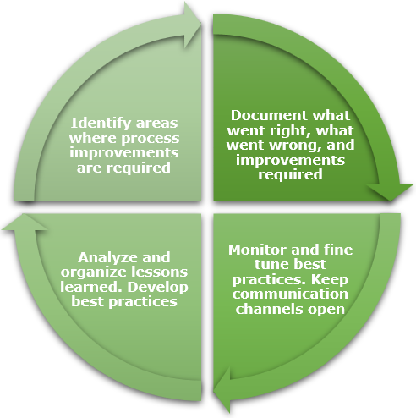
Conclusion: Get to Innovation
The urgency for effective sharable clinical pathways is greater than ever. The core mission of any health system is to improve the health status of its population. Expedient, appropriate decisions are required for the swift, efficient delivery of high-quality primary, secondary, tertiary, and rehabilitative care, based on current scientific evidence and research. Selecting which interventions to prioritize can be difficult, however. It can be even more difficult to determine how to set up the health system to ensure that the appropriate interventions are delivered efficiently. The BPM+ Health Playbook advances the development of innovative approaches to creation and application of sharable clinical pathways of the future with a uniform platform, communication and documentation standards, and care pathway integration.

Appendix
Example assessment
CMM Background

References
Institute of Medicine (US) Committee on Quality of Health Care in America. Crossing the quality chasm: a new health system for the 21st century [Internet]. Washington (DC): National Academies Press (US); 2001 [cited 2021 Mar 22]. Available from: http://www.ncbi.nlm.nih.gov/books/NBK222274/
Welcome to bpm+ health | bpm+ health [Internet]. [cited 2021 Mar 22]. Available from: https://www.bpm-plus.org/
Glossary of Terms
Acronym or Term | Definition
Acquisition | Acquire with appropriated funds of supplies or services (including construction) by and for the use of the Federal Government through purchase or lease, whether the supplies or services are already in existence or must be created, developed, demonstrated, and evaluated. Acquisition begins at the point when agency needs are established and includes the description of requirements to satisfy agency needs, solicitation and selection of sources, award of contracts, contract financing, contract performance, contract administration, and those technical and management functions directly related to the process of fulfilling agency needs by contract.
Acquisition Planning | The process by which the efforts of all personnel responsible for an acquisition are coordinated and integrated through a comprehensive plan for fulfilling the agency need in a timely manner and at a reasonable cost. It includes developing the overall strategy for managing the acquisition.

--- End of Document ---

